ENGINEERING MECHANICS
UNIT-V FRICTION
- A 100N force acts on a 300N block placed on an inclined plane as shown in fig. the coefficients of friction between the block and the plane are µ_{s}=0.25 and µ_{k}=0.20. Determine whether the block is in equilibrium, and find the value of the friction force.
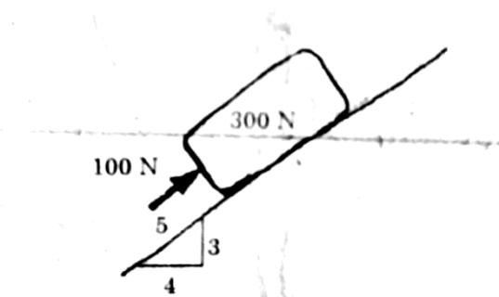
- Block (2) rests on block (1) and is attached by a horizontal rope AB to the wall as shown in fig. what the force P is necessary to cause motion of block (1) to impend? The coefficient of friction between the blocks is 1/4 and between the floor and block (1) is 1/3. Mass of blocks (1) and (2) are 14kg and 9kg respectively.
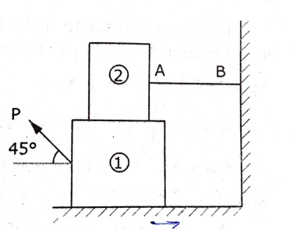
- A block of weight 150N is resting on a rough inclined plane as shown in fig. the block is tied up by a horizontal string, which has a tension of 50N. Find (i) the frictional force on the block (ii) the normal reaction of the inclined plane (iii) the coefficient of friction between the surfaces contact.
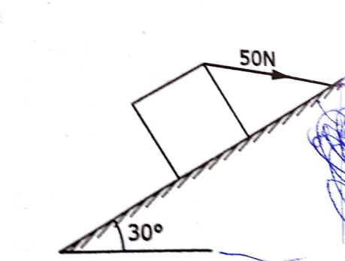

- What should be the value of the angle and tension so that motion of the 390N block impends down the plane? The coefficient of friction µ for all surfaces is 1/3.
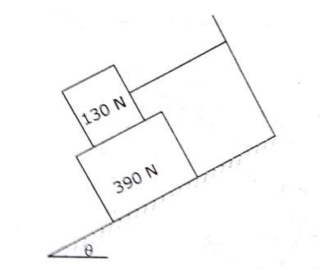

- Block A weighing 1000N rests on a rough inclined plane whose inclination to the horizontal is 45⁰. It is connected to another block B, weighing 3000N rests on a rough horizontal plane by a weightless rigid bar inclined at an angle of 30⁰ to the horizontal as shown in fig. find the horizontal force required to be applied to the block B just to move the block A in upward direction. Assume angle of friction as 15⁰ at all surfaces where there is sliding.
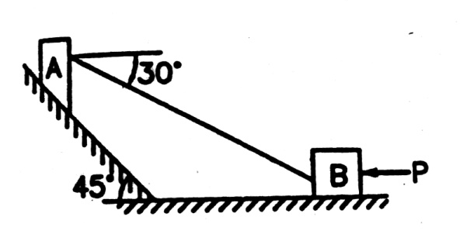

- Find the force P inclined at an angle of 32⁰ to the inclined plane making an angle of 25⁰ with the horizontal plane to slide a block weighing 125KN (i) up the inclined plane (ii) down the inclined plane, when µ=0.5

- A uniform ladder of weight 1000N and of length 4m rests on a horizontal ground and leans against a smooth vertical wall. The ladder makes an angle of 60⁰ with horizontal. When a man of weight 750N stands on the ladder at a distance 3m from the top of the ladder, the ladder is at the point of sliding. Determine the coefficient of friction between the ladder and the floor.

- A 7m ladder rests against a vertical wall, with which it makes an angle of 45⁰ and on a floor. If a man whose weight is one half that of the ladder climbs it, at what distance along the ladder will he be , when the ladder is about to slip? Take coefficient of friction between the ladder and wall is 1/3 and that between the ladder and the floor is 1/2.

- A block overlying a 10⁰ wedge on a horizontal floor and leaning against a vertical wall and weighing 1500N is to be raised by applying a horizontal force to the wedge. Assuming coefficient of friction between all the surfaces in contact to be 0.3, determine the minimum horizontal force to be applied to raise the block.

- A concrete block weighing 10KN is to be shifted away from the wall with the help of a 15⁰ wedge as shown in fig. calculate the magnitude of the vertical force that has to be applied to the top of the wedge to shift the block. The coefficient of friction between all the rubbing surfaces is 0.25
