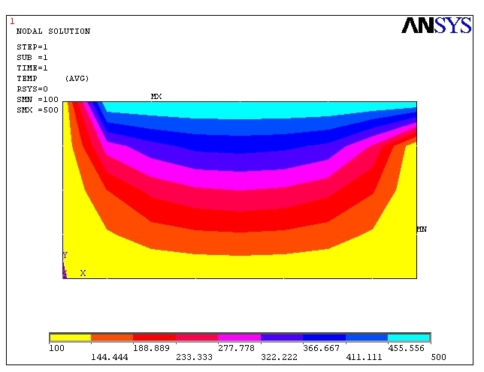
aug 26 2022
14:55:33

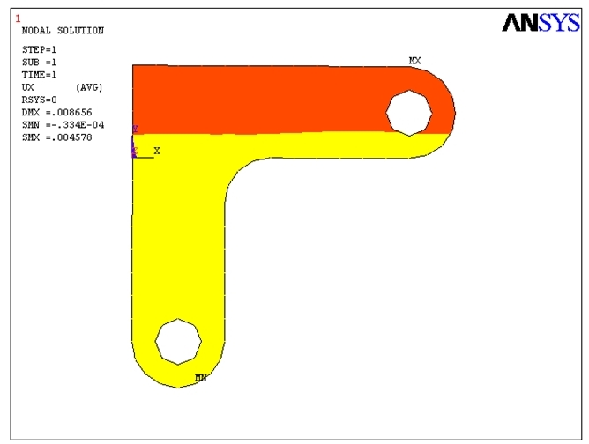
aug 05 2022
14:48:34

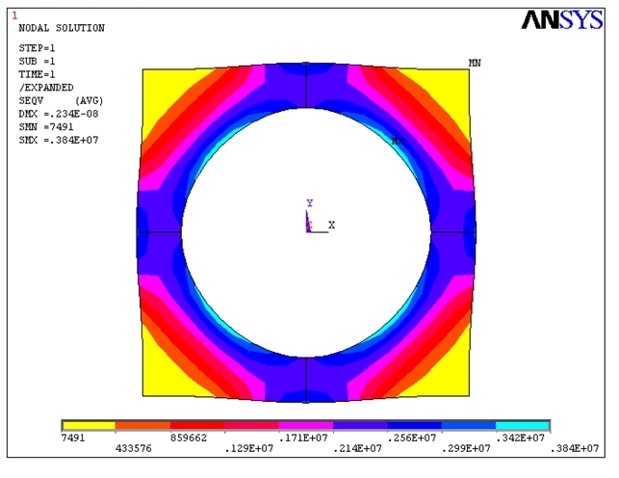
aug 05 2022
14:35:22

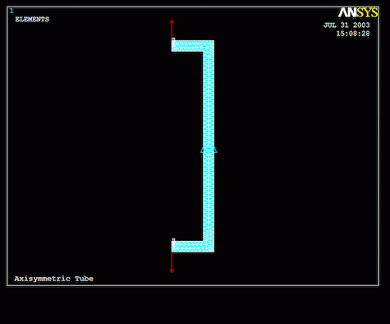
AUG 26 2022
14:55:38

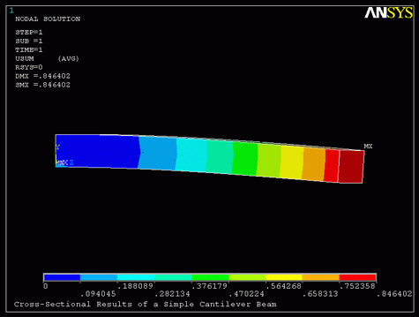
AUG 02 2022
13:46:32

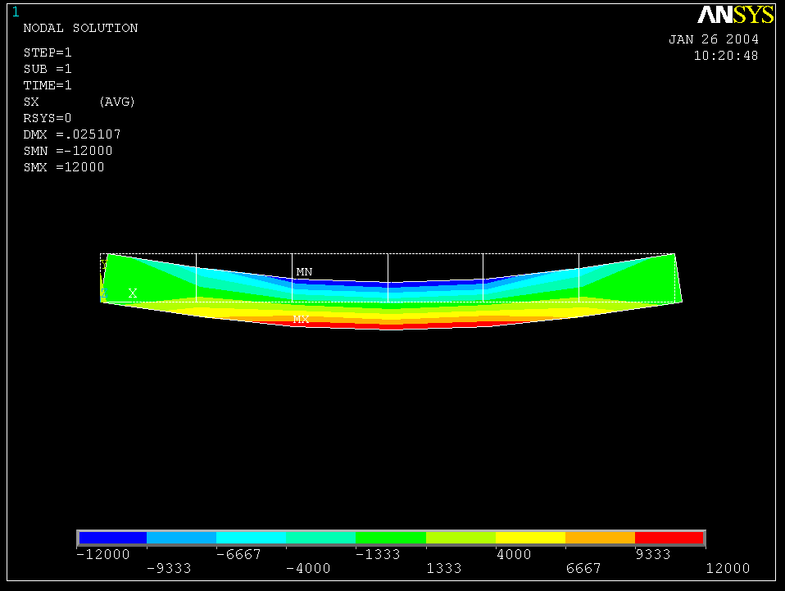
AUG 02 2022
14:45:32

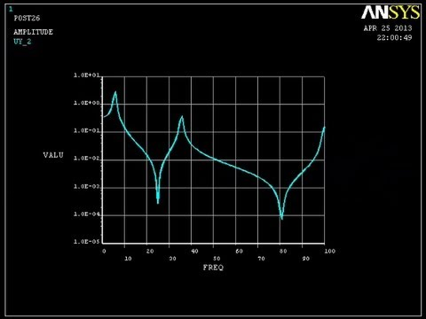
AUG 23 2022
15:18:24

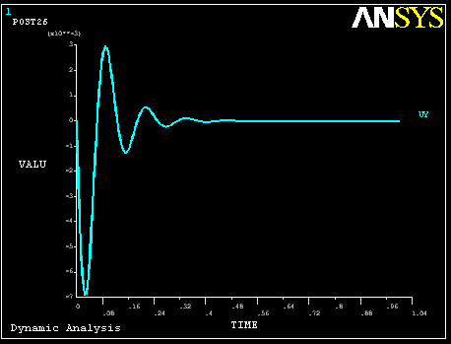
AUG 23 2022
15:40:24

INDEX OF DATA SETS ON RESULTS FILE

SET TIME/FREQ LOAD STEP SUBSTEP CUMULATIVE
1 7554.3 1 1 1
2 38479. 1 2 2
3 48944. 1 3 3
4 88573. 1 4 4
5 0.14324E+06 1 5 5

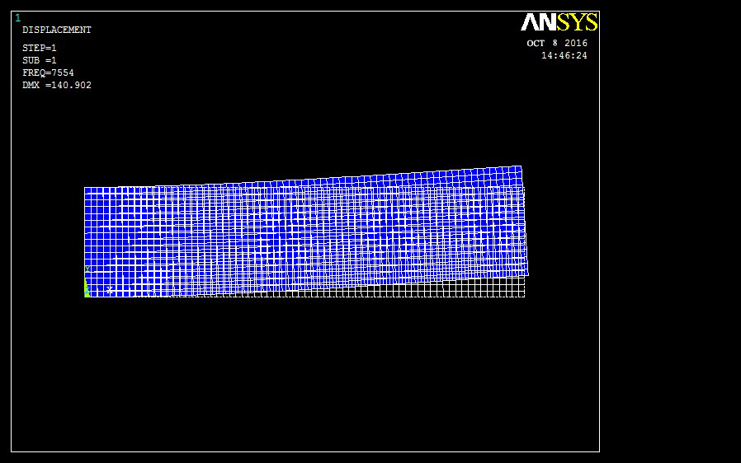
AUG 23 2022
11:21:33

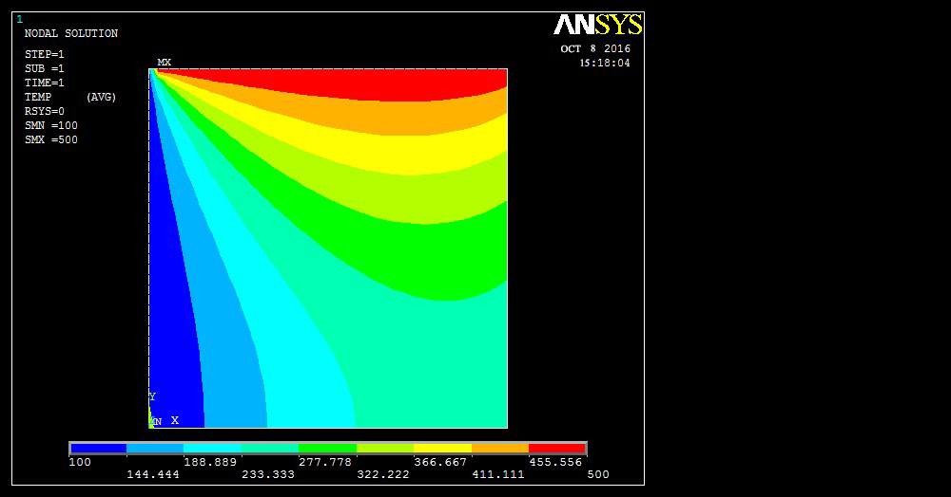
SEP 02 2022
11:14:20

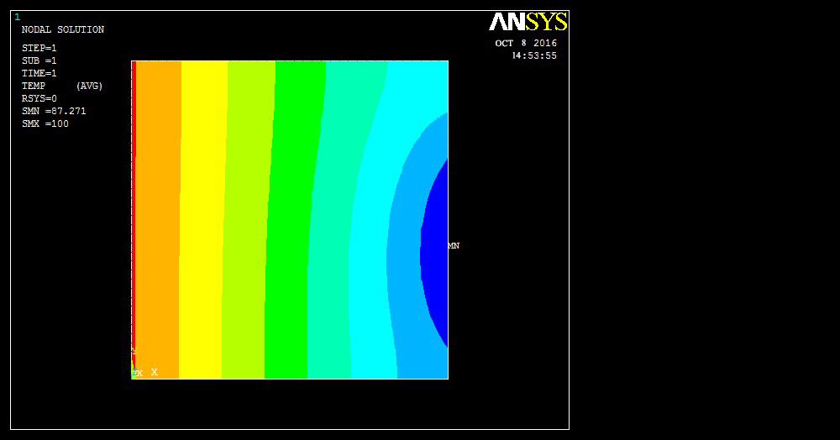
AUG 26 2022
11:17:38

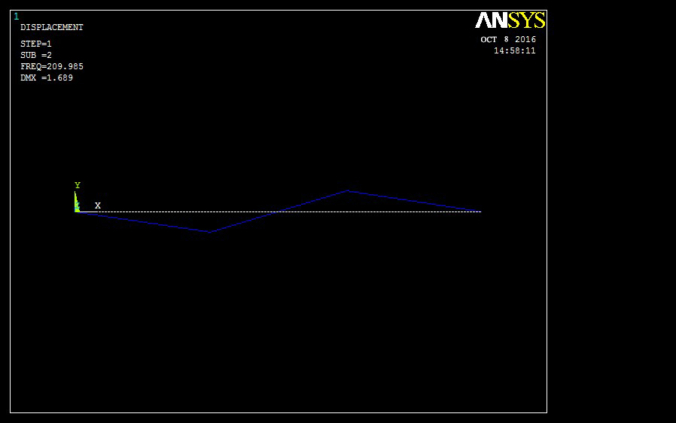
AUG 12 2022
11:26:32

INDEX OF DATA SETS ON RESULTS FILE

SET TIME/FREQ LOAD STEP SUBSTEP CUMULATIVE
1 75.014 1 1 1
2 209.98 1 2 2
3 488.13 1 3 3
4 969.16 1 4 4
5 2688.0 1 5 5

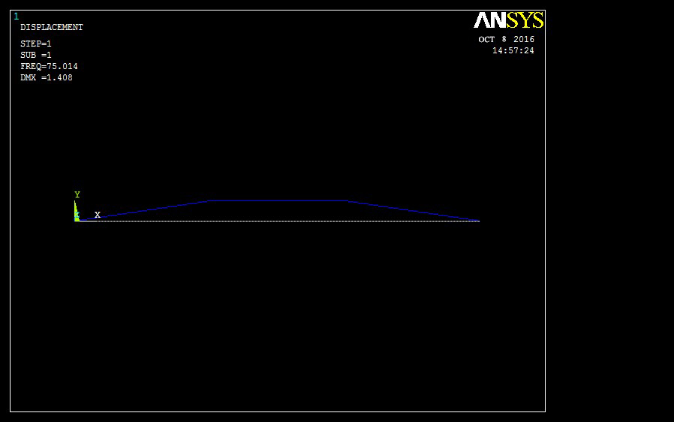
AUG 12 2022
11:16:32

INDEX OF DATA SETS ON RESULTS FILE

SET TIME/FREQ LOAD STEP SUBSTEP CUMULATIVE
1 11.742 1 1 1
2 73.806 1 2 2
3 208.47 1 3 3
4 469.15 1 4 4
5 882.06 1 5 5

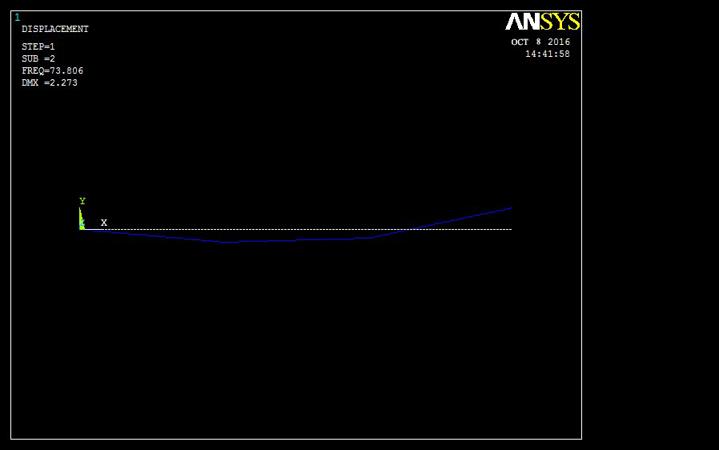
AUG 12 2022
11:10:22

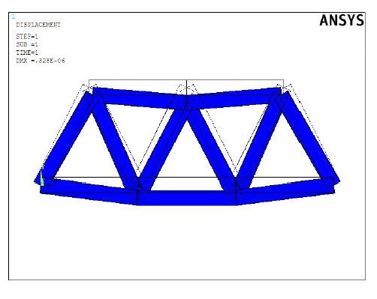
SEP 13 2022
14:55:33

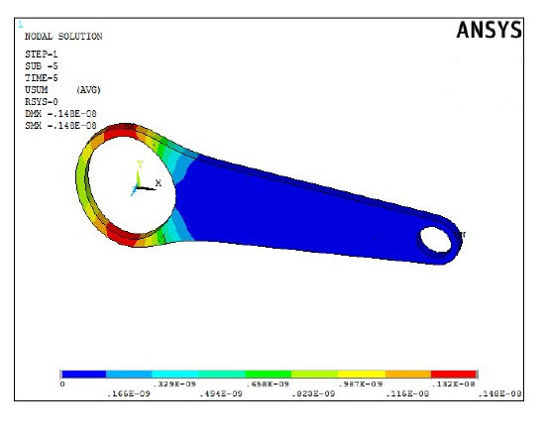
SEP 20 2022
14:45:33

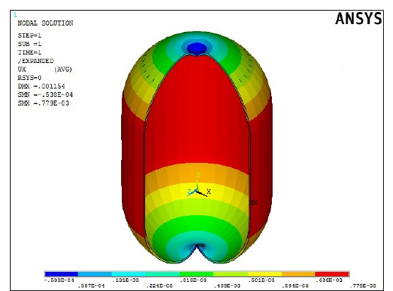
SEP 16 2022
14:25:23

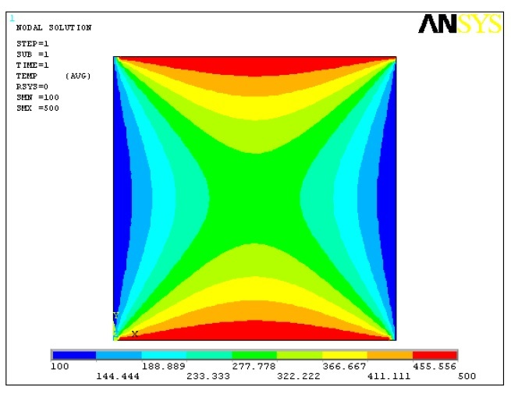
SEP 02 2022
14:35:23

