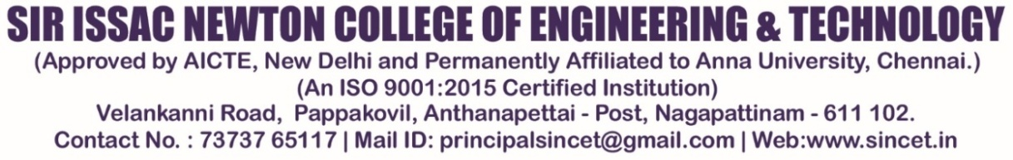
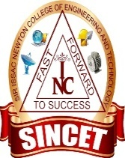
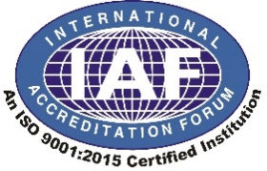
.

Department of MECHANICAL ENGINEERING

SUBJECT CODE & NAME: ME8595 THERMAL ENGINEERING II

Program Educational Objectives (PEO) & Program Specific Outcomes (PSO)

PEO
- To demolish to the solutions of real life problems applying the skills of basic science, engineering design, manufacturing, thermal science and management.
- To mentoring the students to effectively participate in multidisciplinary projects for the development of our society.
- To forge awareness among the students in the fields of research and development in mechanical engineering and other allied fields.

PSO
- Potentially to apply the concepts of Mechanical Engineering fields to design mechanical systems and processes.
- Strength to demonstrate professional and entrepreneurial skills to meet the industrial requirements.

PROGRAMME OUTCOMES
PO1 | Engineering knowledge  Apply the knowledge of mathematics, science, engineering fundamentals, and an engineering specialization to the solution of complex engineering problems.
PO2 | Problem analysis  Identify, formulate, review research literature, and analyze complex engineering problems reaching substantiated conclusions using first principles of mathematics, natural sciences, and engineering sciences.
PO3 | Design/development of solutions  Design solutions for complex engineering problems and design system components or processes that meet the specified needs with appropriate consideration for the public health and safety, and the cultural, societal, and environmental considerations
PO4 | Conduct investigations of complex problems  Use research-based knowledge and research methods including design of experiments, analysis and interpretation of data, and synthesis of the information to provide valid conclusions
PO5 | Modern tool usage  Create, select, and apply appropriate techniques, resources, and modern engineering and IT tools including prediction and modeling to complex engineering activities with an understanding of the limitations.
PO6 | The engineer and society  Apply reasoning informed by the contextual knowledge to assess societal, health, safety, legal and cultural issues and the consequent responsibilities relevant to  the professional engineering practice
PO7 | Environment and sustainability  Understand the impact of the professional engineering solutions in societal and environmental contexts, and demonstrate the knowledge of, and need for sustainable development
PO8 | Ethics  Apply ethical principles and commit to professional ethics and responsibilities and norms of the engineering practice.
PO9 | Individual and team work  Function effectively as an individual, and as a member or leader in diverse teams, and in multidisciplinary settings
PO10 | Communication  Communicate effectively on complex engineering activities with the engineering community and with society at large, such as, being able to comprehend and write effective reports and design documentation, make effective presentations, and give and receive clear instructions
PO11 | Project management and finance  Demonstrate knowledge and understanding of the leader in a team, to manage projects and in multidisciplinary environments
PO12 | Life-long learning  Recognize the need for, and have the preparation and ability to engage in independent and life-long learning in the broadest context of technological change.

ME8595 THERMAL ENGINEERING II
Regulation– 2017

SYLLABUS
OBJECTIVES:
• To apply the thermodynamic concepts for Nozzles, Boilers, Turbines, and Refrigeration & Air Conditioning Systems.
• To understand the concept of utilising residual heat in thermal systems.

UNIT I STEAM NOZZLE 9
Types and Shapes of nozzles, Flow of steam through nozzles, Critical pressure ratio, Variation of mass flow rate with pressure ratio. Effect of friction. Metastable flow.

UNIT II BOILERS 9
Types and comparison. Mountings and Accessories. Fuels - Solid, Liquid and Gas. Performance calculations, Boiler trial.

UNIT III STEAM TURBINES 9
Types, Impulse and reaction principles, Velocity diagrams, Work done and efficiency – optimal operating conditions. Multi-staging, compounding and governing.

UNIT IV COGENERATION AND RESIDUAL HEAT RECOVERY 9
Cogeneration Principles, Cycle Analysis, Applications, Source and utilisation of residual heat. Heat pipes, Heat pumps, Recuperative and Regenerative heat exchangers. Economic Aspects.

UNIT V REFRIGERATION AND AIR – CONDITIONING 9
Vapour compression refrigeration cycle, Effect of Superheat and Sub-cooling, Performance calculations, Working principle of air cycle, vapour absorption system, and Thermoelectric refrigeration. Air conditioning systems, concept
TOTAL : 45 PERIODS

COURSE OUTCOME:

No of co’s
CO-1 | Solve problems in Steam Nozzle
CO-2 | Explain the functioning and features of different types of Boilers and auxiliaries  And calculate performance parameters.
CO-3 | Explain the flow in steam turbines, draw velocity diagrams for steam turbines and  solve problems.
CO-4 | Summarize the concept of Cogeneration, Working features of Heat pumps and Heat  exchangers
CO-5 | Solve problems using refrigerant table / charts and psychrometric charts

TEXT BOOKS:

1. Kothandaraman, C.P., Domkundwar .S and Domkundwar A.V.,”A course in Thermal Engineering”, Dhanpat Rai & Sons, 2016.
2. Mahesh. M. Rathore, “Thermal Engineering”, 1st Edition, Tata Mc Graw Hill Publications, 2010.

REFERENCES:

1. Arora .C.P., “Refrigeration and Air Conditioning”, Tata Mc Graw Hill, 2008
2. Ballaney. P.L ." Thermal Engineering”, Khanna publishers, 24th Edition 2012
3. Charles H Butler : Cogeneration” McGraw Hill, 1984.
4. Donald Q. Kern, “ Process Heat Transfer”, Tata Mc Graw Hill, 2001.
5. Sydney Reiter “Industrial and Commercial Heat Recovery Systems” Van Nostrand Reinhols, 1985.

STAFF INCHARGE HEAD OF THE DEPARTMENT

