**B.E / B.Tech PRACTICAL SEMESTER EXAMINATIONS, DECEMBER 2020**

Third Semester

Mechanical Engineering

ME8361- Manufacturing Technology Laboratory-I

(Common to Industrial Engineering and Management, Industrial Engineering, Manufacturing Engineering and Mechanical Engineering (Sandwich)

(Regulation 2017)

Time : 3 Hours Max. Marks 100

|  |  |  |  |  |  |
| --- | --- | --- | --- | --- | --- |
| Aim/Apparatus required/ Procedure | Drawing/Finished job | Result | Viva-Voce | Record | Total |
| 20 | 50 | 10 | 10 | 10 | 100 |

1. Machine the given cylindrical rod as per the diagram, by using the lathe machine

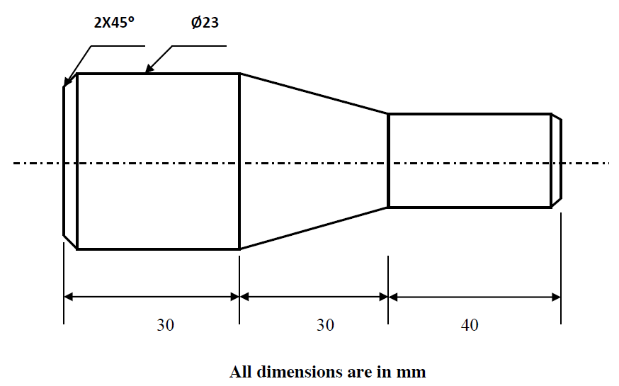

1. Machine the given cylindrical rod as per the diagram, by using the lathe machine.

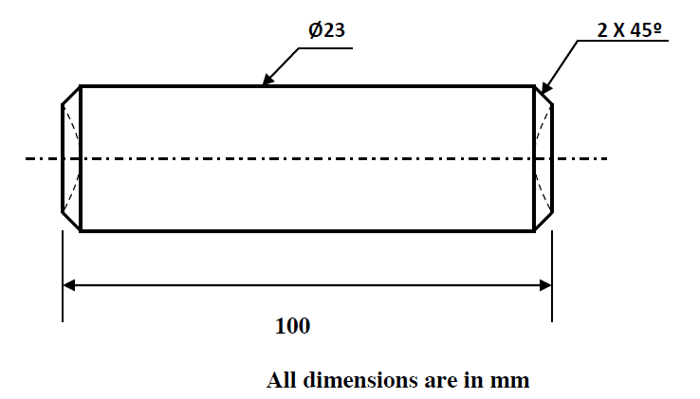

1. Machine the given cylindrical rod as per the diagram, by using the lathe machine.

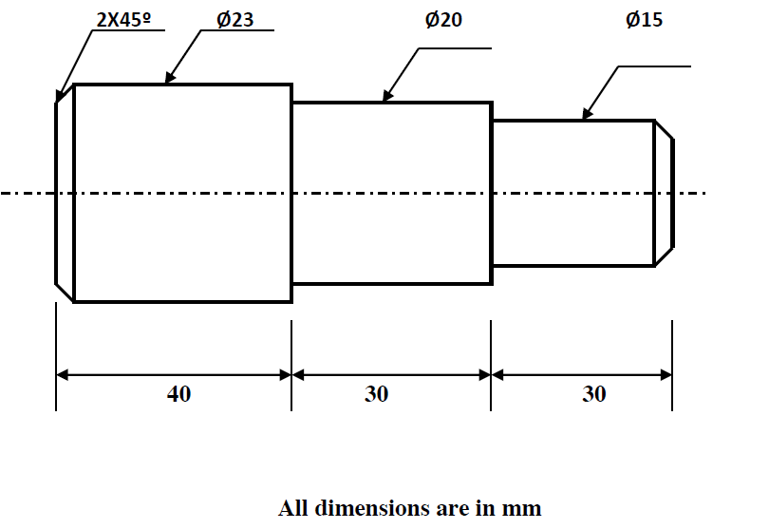

1. Perform boring on a cylindrical work piece.

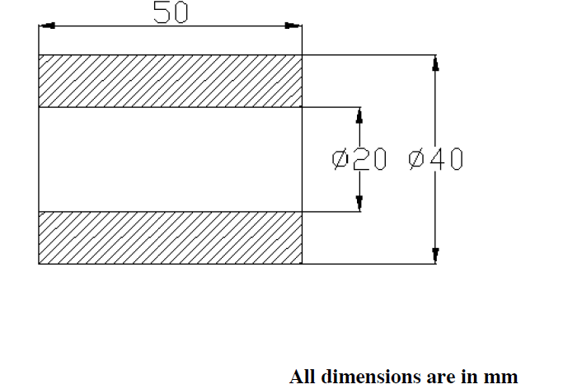

1. Machine the given cylindrical rod as per the diagram, by using the lathe machine.

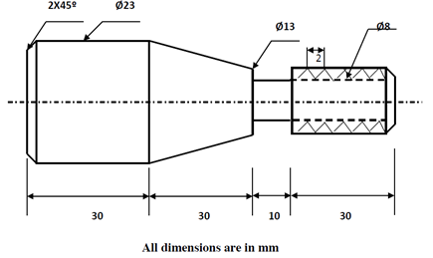

1. Machine the given cylindrical rod as per the diagram, by using the lathe machine.

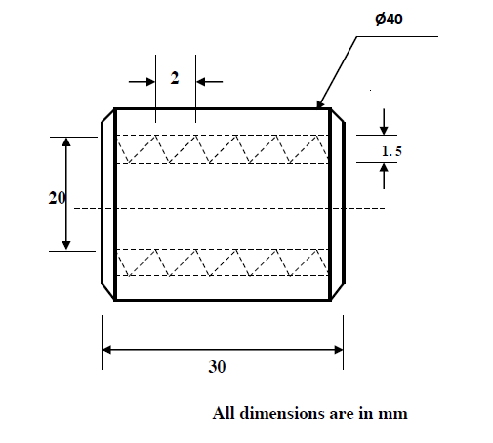

1. Machine the given cylindrical rod as per the diagram, by using the lathe machine.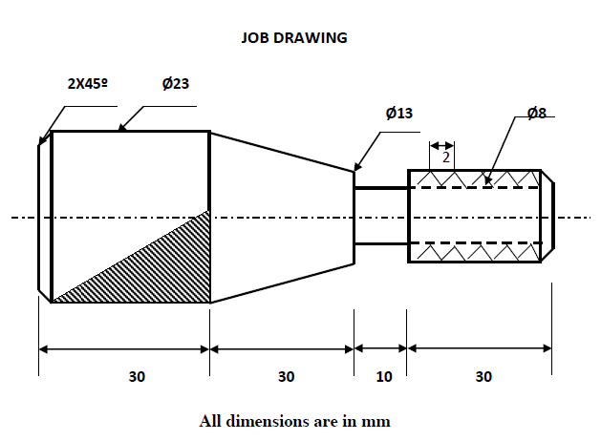
2. Machine the given cylindrical rod as per the diagram, by using the lathe machine.

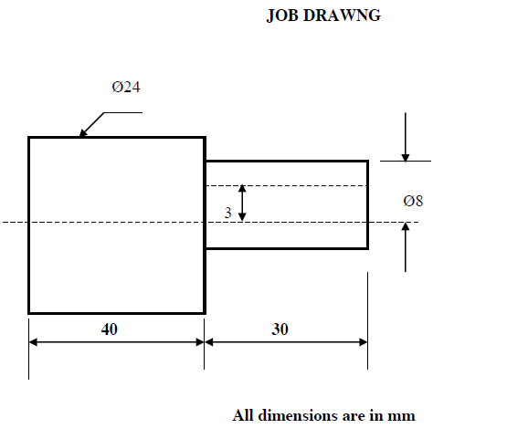

1. Machine the given rectangular block in the shaping machine

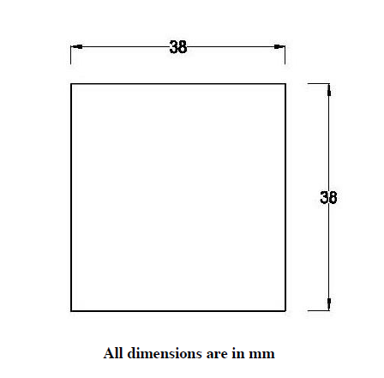

1. Machine a hexagon in the given work piece to the dimensions as shown in the figure using Shaping Machine

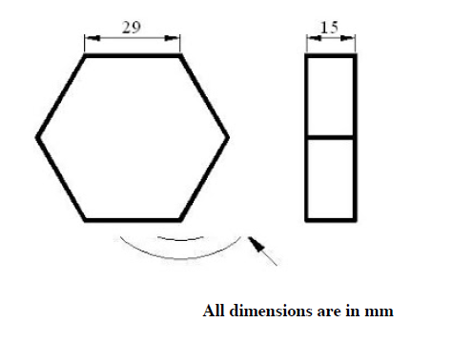

1. Make a rectangular tray from the given sheet metal.

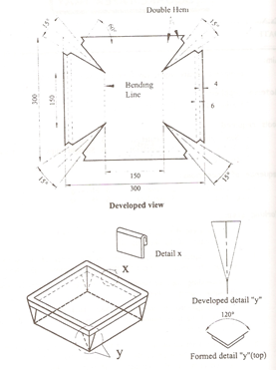

1. Machine the given cylindrical rod as per the diagram, by using the lathe machine.

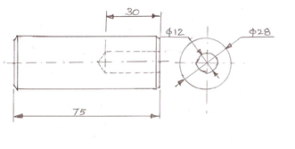

1. To machine the given cylindrical rod as per the diagram, by using the lathe machine.

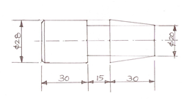

1. Join the given two work pieces as a lap joint by arc welding.

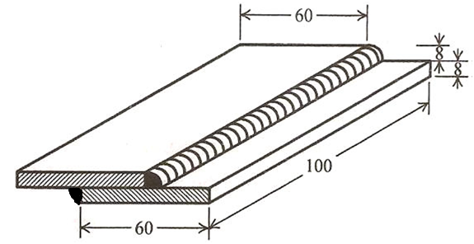

1. To join the given two work pieces as a single ‘v’ butt joint by arc welding

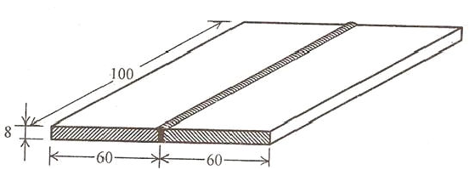

1. Tojointhegiventwoworkpiecesasa‘T’jointbyarcwelding

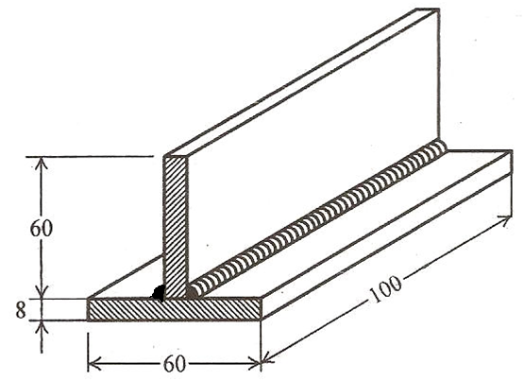

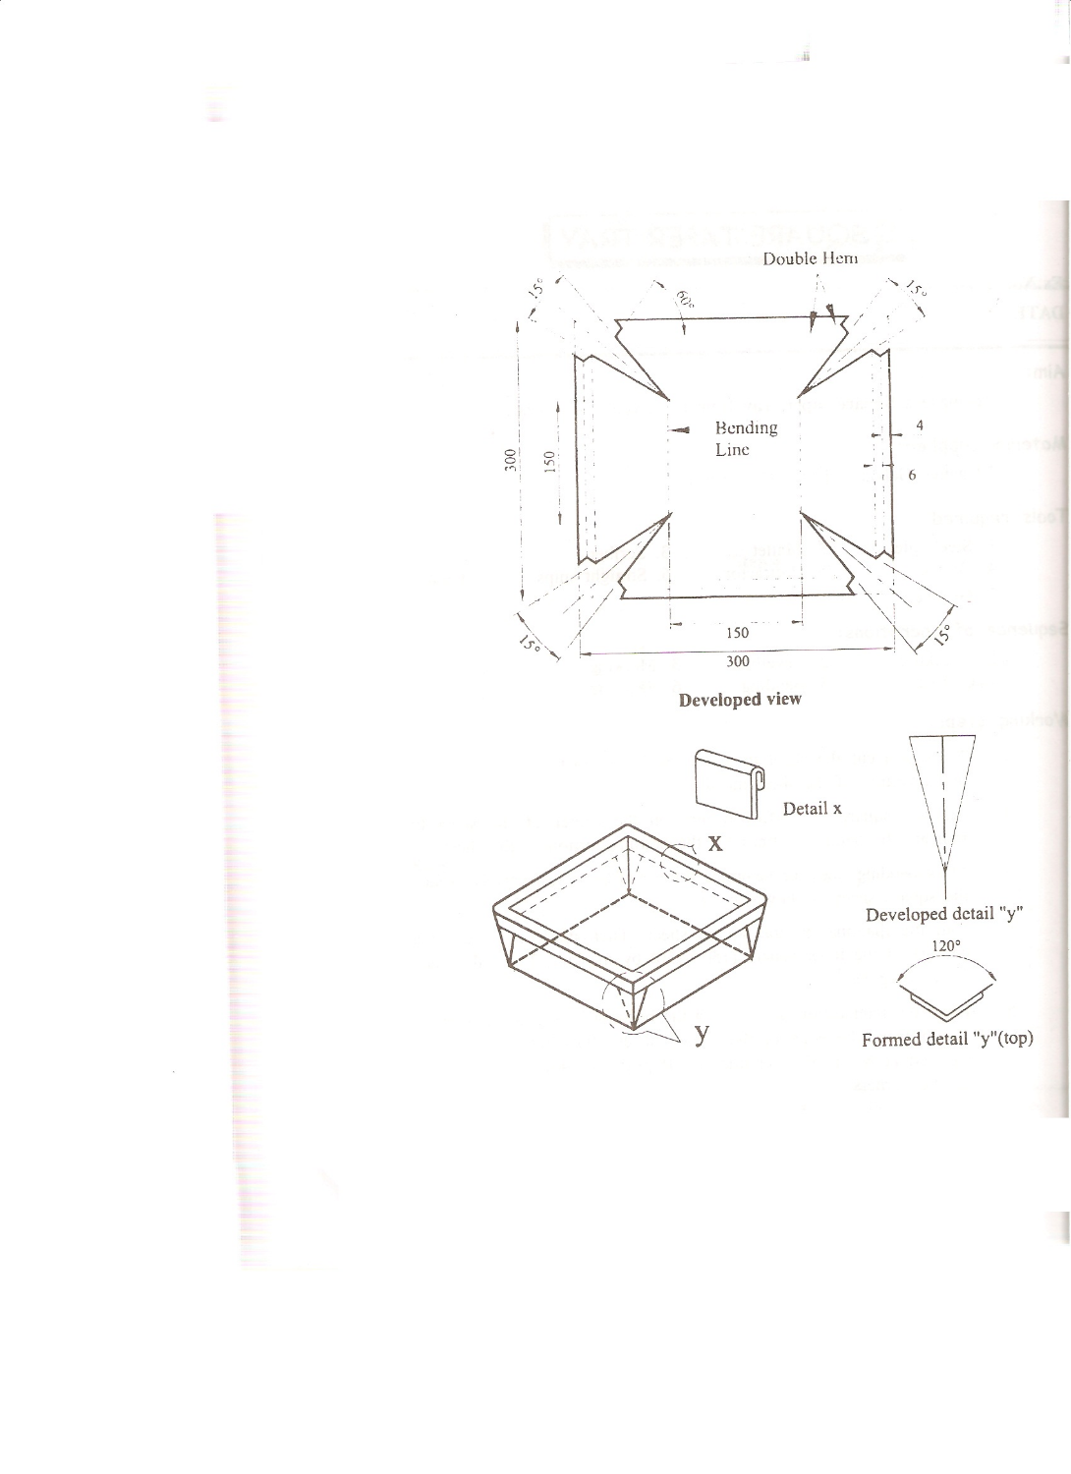

1. To prepare the green sand mold for given split pattern.



1. To make a scoop from the given sheet metal.

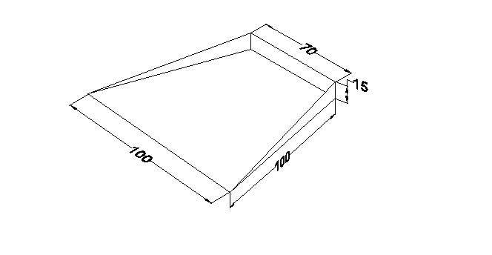

1. To make a funnel from the given sheet metal.

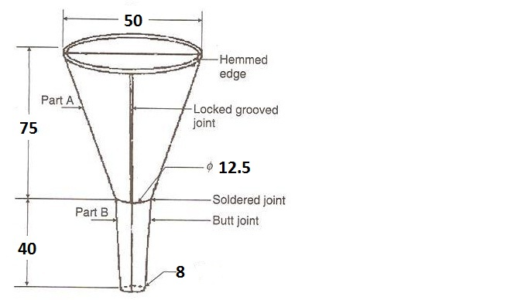

1. To prepare the green sand mold for given solid pattern.

