-ANNA UNIVERSITY: CHENNAI-600 025

B.E./B.Tech. DEGREE EXAMINATIONS, NOV./DEC.-2020

Regulation – 2013 Seventh Semester
(Common to B.E. Mechanical Engineering / B.E. Mechanical and Automation Engineering
/B.E. Production Engineering)

ME6711 – Simulation and Analysis Laboratory

Time : 3 Hours Marks : 100

- Compute the Shear force and bending moment diagrams for the cantilever beam shown and find the maximum deflection. Assume rectangular c/s area of 0.2 m * 0.3 m, Young’s modulus of 210GPa, Poisson’s ratio 0.27. (100)
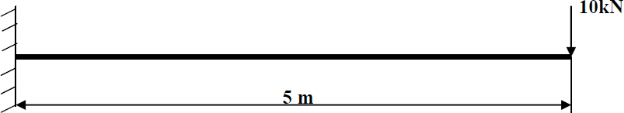

- Compute the Shear force and bending moment diagrams for the cantilever beam shown and find the maximum deflection. Assume rectangular c/s area of 0.2 m * 0.3 m, Young’s modulus of 210GPa, Poisson’s ratio 0.27. (100)
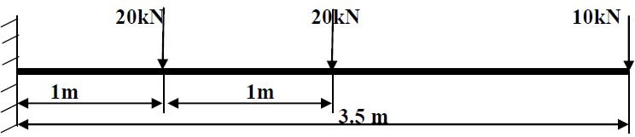

- Compute the Shear force and bending moment diagrams for the simply supported beam shown and find the maximum deflection. Assume rectangular c/s area of 0.2 m
  - 0.3 m, Young’s modulus of 210GPa, Poisson’s ratio 0.27. (100)

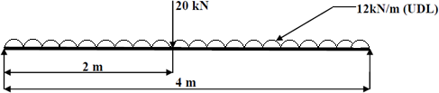

- Compute the Shear force and bending moment diagrams for the simply supported beam shown and find the maximum deflection. Assume rectangular c/s area of 0.2 m
  - 0.3 m, Young’s modulus of 210GPa, Poisson’s ratio 0.27. (100)
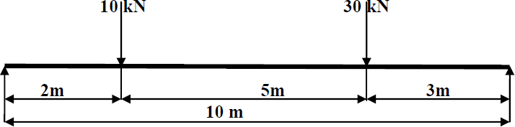

- Compute the Shear force and bending moment diagrams for the simply supported beam shown and find the maximum deflection. Assume rectangular c/s area of 0.2 m
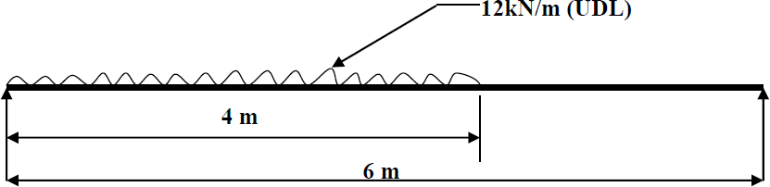
  - 0.3 m, Young’s modulus of 210GPa, Poisson’s ratio 0.27. (100)

- Compute the Shear force and bending moment diagrams for the simply supported beam shown and find the maximum deflection. Assume rectangular c/s area of 0.2 m
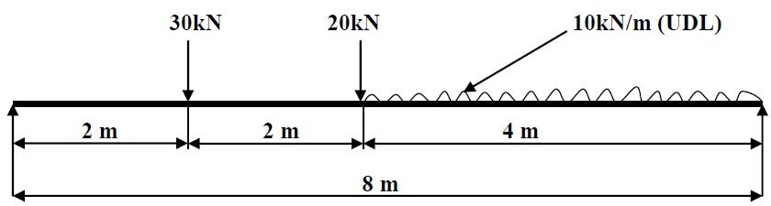
  - 0.3 m, Young’s modulus of 210GPa, Poisson’s ratio 0.27. (100)

.

- A distributed load of 10 N/mm will be applied to a solid steel beam with a rectangular cross section as shown in the figure below. The cross-section of the beam is 10mm x 10mm while the modulus of elasticity of the steel is 210GPa. (100)

- Compute the stress and deflection in a distributed load of 1000 N/m (1 N/mm) will be applied to a solid steel beam with a rectangular cross section as shown in the figure below. The cross-section of the beam is 10mm x 10mm while the modulus of elasticity of the steel is 200GPa. (100)
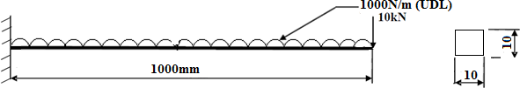

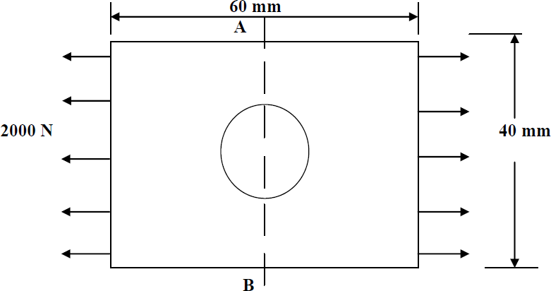
- In the plate with a hole under plane stress, find deformed shape of the hole and determine the maximum stress distribution along A-B (you may use t = 1 mm). E = 210GPa, t = 1 mm, Poisson’s ratio = 0.3, Diameter of the circle = 10 mm, Analysis assumption – plane stress with thickness is used. (100)

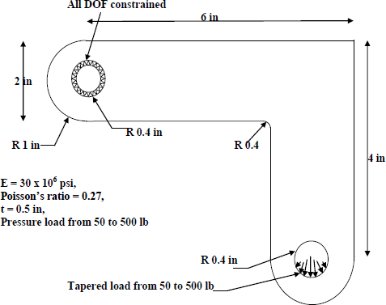
- The corner angle bracket is shown below. The upper left hand pin-hole is constrained around its entire circumference and a tapered pressure load is applied to the bottom of lower right hand pin-hole. Compute Maximum displacement, Von-Mises stress. (100)

- Solve the 2-D heat conduction problem for the temperature distribution within the
rectangular plate. Thermal conductivity of the plate, KXX=401 W/m-K (100)
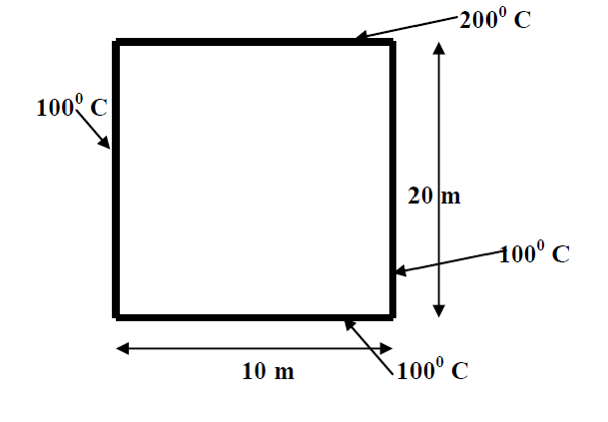

- Solve the Simple Conduction problem constrained as shown in the following figure. Thermal conductivity (k) of the material is 10 W/m*C and the block is assumed to be
infinitely long. (100)
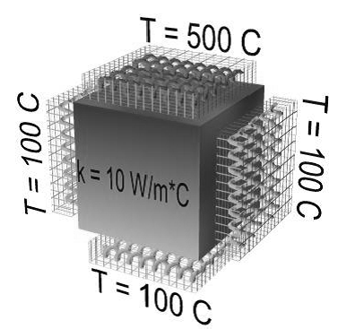

- Solve the

simple

thermal conduction as

well

a mixed

conduction/convection/insulation is
constrained
as shown
in the following figure.

Note that Thermal conductivity (k) of the material is 10 W/m*C and the section is
assumed to be infinitely long (100)
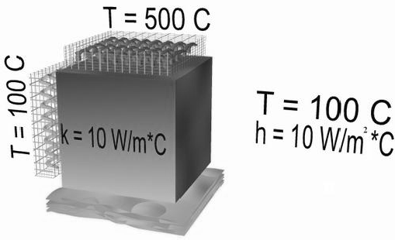

- For the two-dimensional stainless-steel shown
below, determine the
temperature

distribution. The left and right sides are insulated. The top surface is subjected to heat transfer by convection. The bottom and internal portion surfaces are maintained at
300 °C. Thermal conductivity of stainless steel = 16 W/m K (100)
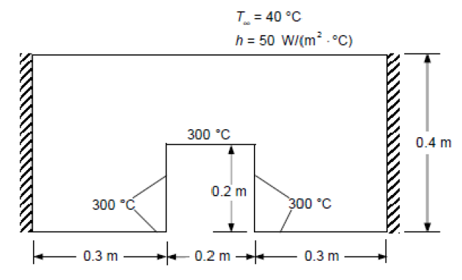

- Determine the natural frequency for modal analysis of Cantilever beam Modulus of elasticity = 200GPa, Density = 7800 Kg/m3. (100)
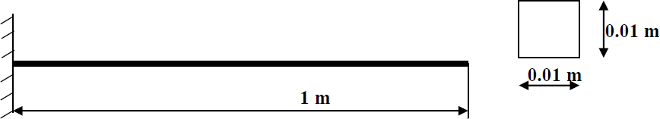

- Determine the natural frequency for modal analysis of simply supported beam Modulus of elasticity = 200GPa, Density = 7800 Kg/m3. (100)

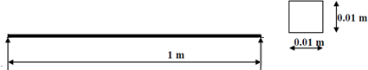

- Conduct a harmonic forced response test by applying a cyclic load (harmonic) at the end of the beam. The frequency of the load will be varied from 1 - 100 Hz. Modulus of elasticity = 200GPa, Poisson’s ratio = 0.3, Density = 7800 Kg/m3. (100)

- Compute a large, thin, square plate of side‘s’ containing a small circular hole of radius ‘a’ at its center. The plate is subjected to simple tensile stress of σ_{o} = 1x10⁶ N/m2 on its vertical edges. The sides of the plate are s = 2m and the radius of the hole is a = 0.1m. The plate is 0.001m thick and is made of aluminum with Young’s modulus E = 0.7x1011 N/m2, and Poisson’s ratio ν = 0.3. (100)
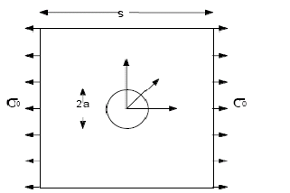

- A steel plate with 3 holes 3mm, 5mm & 10 mm respectively is supported and loaded, as shown in figure. We assume that the support is rigid (this is also called built-in support or fixed support) and that the 20 KN tensile load is uniformly distributed on the end face, opposite to the supported face. The cross section is 15 mm x 25 mm. length is 100mm. Material (Alloy steel) (100)

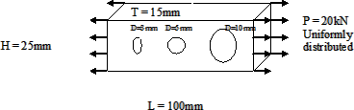

- An L-shaped bracket is supported and loaded as shown in figure 3-1. We wish to find

the Displacements and
stresses caused by a
5,000 N which is 60°
inclined. In

particular, we are interested in stresses in the corner where the 5 mm round edge
(fillet) is located. Material is Grey Cast Iron. (100)
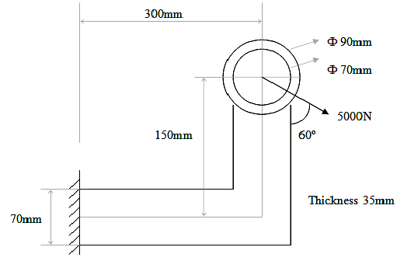

- Compute the stresses and deflections in the pressure vessel walls due to the internal pressure. The pressure vessel shown below is made of cast iron (E = 14.5 Msi, ν = 0.21) and contains an internal pressure of p = 1700 psi. The cylindrical vessel has an inner diameter of 8 in with spherical end caps. The end caps have a wall thickness of
0.25 in, while the cylinder walls are 0.5 in thick. In addition, there are two small circumferential grooves of 1/8 in radius along the inner surface, and a 2 in wide by

0.25 in deep surface.
circumferential groove at the center of the
cylinder along the outer
(100)

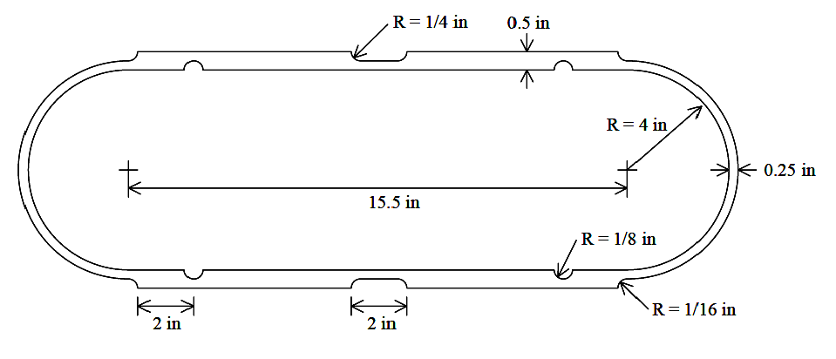

Mark Allocation

Online Test | Aim & Procedure &Design steps | Results | Viva Voce | Total
15 | 65 | 10 | 10 | 100

