ANNA UNIVERSITY: CHENNAI – 600 025

B.E./B.Tech. DEGREE EXAMINATIONS, NOVEMBER/DECEMBER 2020

Regulations – 2013 Seventh Semester
(B.E Mechanical Engineering/ B.E Mechanical and Automation Engineering/ B.E Production Engineering)
ME6711- Simulation and Analysis Laboratory

Time: 3 Hours Maximum Marks: 100
ALLOCATION OF MARKS

SL.  NO | DESCRIPTION | MAX MARKS
1 | ONLINE TEST | 15
2 | AIM, PROCEDURE,DESIGN STEPS | 65
3 | RESULT | 10
4 | VIVA VOCE | 10
TOTAL |  | 100

- Simulate the operation of an air conditioning system with condenser temperature and evaporator temperatures as input to get COP using C/ MATLAB. Also find the COP for the following cases
Case  No. | Condenser Temperature  °C | Evaporator Temperature  °C
1. | 34 | 23
2. | 30 | 18

- Simulate the operation of Hydraulic/Pneumatic cylinder using C / MATLAB. Also illustrate with an example.

- Simulate the function of cam and follower mechanism with the following specification using C
/ MATLAB;

Type of motion Speed of cam shaft Type of follower  Base circle radius | : -  : -  : -  : - | uniform velocity 250 rpm  Knife edged follower  50 mm
Cam Lift | : - | 40 mm
Angle of lift | : - | 120°
Angle of return | : - | 120°
Remaining period Dwell

- A rectangular plate with a circular hole of thickness t =10 mm is subjected a tensile load of 100kN as shown in fig. Determine the displacement and stress caused by the load using analysis software. Take E=2x10⁵ N/mm² and Poisson’s ratio 0.3.
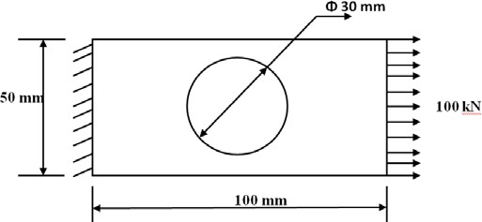

- Structural analysis of the steel bracket used to support bookshelves is shown in fig. The thickness of the bracket is 3.125 mm. The structure is made of steel (ASTM A365) with modulus of elasticity E=200GPa. The Poisson’s ratio=0.3. The bracket is loaded uniformly along its top surface. The load is 2625 N/m. Plot deformed shape and the Von-Misses stress using analysis software.
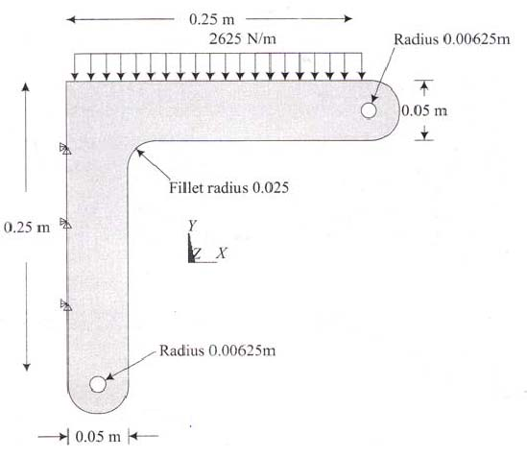

- A Steel pressure vessel with planar ends is subjected to an internal pressure of 35 MPa. The vessel has an outer diameter of 200 mm, an over-all length of 400 mm and a wall thickness of 25 mm. there is a 25 mm fillet radius where the interior wall surface joins the end cap as shown in fig. Take the material properties as E= 200 GPa, Poisson’s ratio=0.3 and yield strength =330 MPa. Determine the radial stresses, axial stresses and deformation of the vessel using analysis software by adapting axisymmetric element.
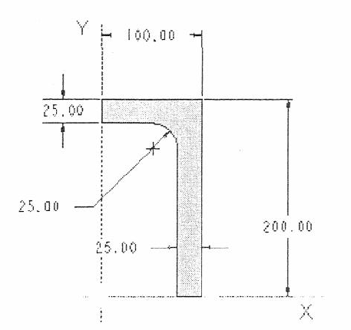

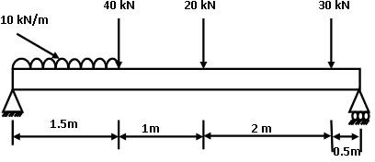
- A distributed load & Point load will be applied to a solid AISI 4340 steel beam with a rectangular cross section as shown in the figure below. The cross-section of the beam is 150mm x 300mm while the modulus of elasticity of the steel is 210 GPa. Find reaction, deflection and stresses in the beam using analysis software.

- A distributed load & Point load will be applied to a brass (E=102 GPa) beam with a rectangular cross section as shown in the figure below. The cross-section of the beam is 100mm x 200mm. Find reaction, deflection and stresses in the beam using analysis software.
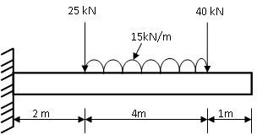

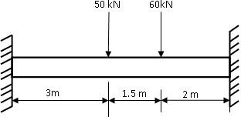
- A distributed load & Point load will be applied to a grey cast iron (E=130 GPa) beam with a rectangular cross section as shown in the figure below. The cross-section of the beam is 300 mm x 250 mm. Find reaction, deflection and stresses in the beam using analysis software.

- Obtain the lowest three vibration modes and resonant frequencies using analysis software in the y direction of the straight steel bar Thickness of the bar is 0.005 m, width is 0.01 m, and the length is 0.09 m. Material of the bar is steel with Young’s modulus, E =206 GPa, and Poisson’s ratio ν=0.3. Density ρ=7.8×10³ kg/m³.
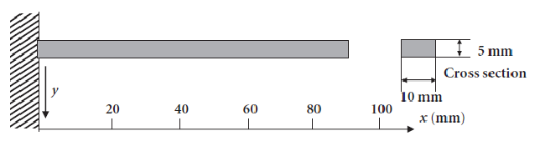

- Determine the natural frequency of a simply supported beam of 0.5m long and of rectangular cross section 15 mm wide and 30 mm deep and it is made up of aluminum material (E=70 GPa and density ρ= 2700 kg/m³ (self-weight = 5.4 kg/m)). Use Appropriate Analysis software.

- Determine the first two natural frequencies of the simply supported beam with rectangular cross section shown in Fig. using analysis software.
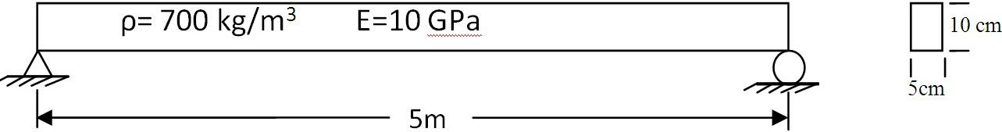

- Consider a square plate 10 × 10 cm of thickness 10 mm, K=0.7 W/m °C. The left end of the plate is kept at 120 °C and the right end is exposed to cold air at 15 °C, other two ends are insulated. The heat transfer coefficient associated with outer surface is h= 40 W/m² °C. Determine the steady state temperature distribution of the plate by assuming it as 2D component using analysis software.

- Obtain the resonant frequency of a one-axis moving table using elastic hinges when the bottom of the table is fixed and a piezoelectric actuator is selected as an actuator:
  - Material: Steel, thickness of the table: 5mm (All Dimensions are in mm)
  - Young’s Modulus, E =207 GPa, Poisson’s ratio ν=0.3
  - Density ρ=7.86×10³ kg/m³
  - Boundary condition: All freedoms are constrained at the bottom of the table and the region A indicated in Figure where a piezoelectric actuator is glued. Use Appropriate Analysis software.

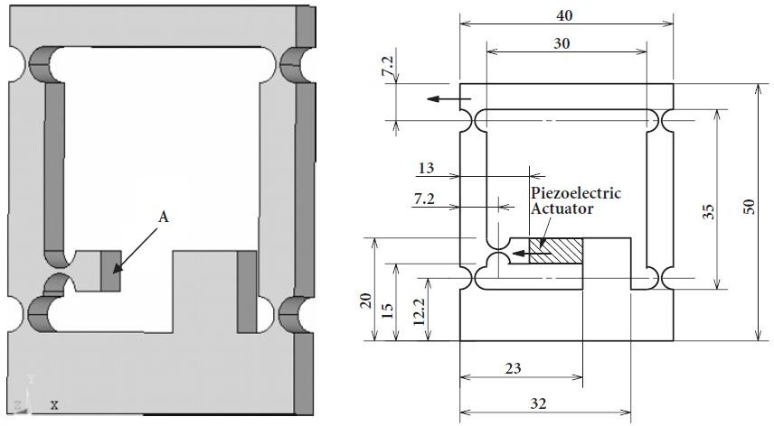

- The cross sectional area of the Grey Cast Iron (E=130 GPa) solid flywheel is shown below. The flywheel is subjected to a torque of 100kNm. Find the stress distribution using appropriate analysis software by adapting Axisymmetric method. Filet radius is 5 mm.

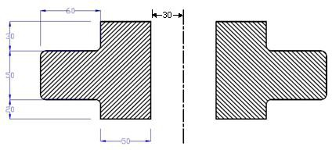
All dimensions are in mm

- The cantilever beam is having uniform I cross section as shown in fig. The beam is fixed to the body on one end and hangs freely at the other and it is made up of Polyethylene HDPE (high density), E=0.8 GPa. The length of the beam is 10 m. determine the natural frequencies of the beam using analysis software.
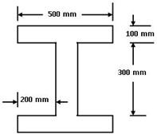

- A copper flat measuring 60 mm x 30 mm is brazed to another 60 mm x 60 mm mild steel flat as shown in fig. If right end of the plates heated to 120 °C, determine the thermal stress produced and the deflection caused due to heating using analysis software. Take thermal expansion of copper α_{c} =18.5 x 10⁻⁶ per °C, Thermal expansion of steel α_{s} =12 x 10⁻⁶ per °C, Young’s Modulus of copper E_{c} =110 GPa and Young’s modulus of steel E_{s} =220 GPa. Length of the flat plate is 400 mm.

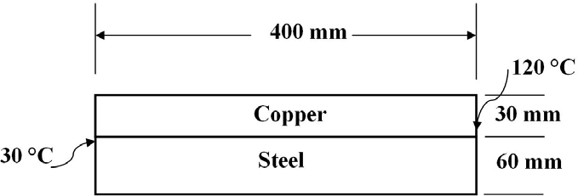

- For the two-dimensional body shown in fig. determine the temperature distribution using analysis software. The left and right sides are insulated. The top surface is subjected to heat transfer by convection. The bottom and internal portion surfaces are maintained at 300⁰C. Use thickness as 0.01m and material as Aluminium (K=200 W/m °C).
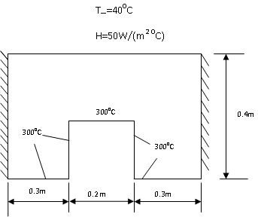

- The bottom surface of the fin is exposed to a constant heat flux of q=1000 W/m. Air flows over the developed surface keeping the surrounding temperature at 293 K. Heat transfer coefficient between the fin and the surrounding atmosphere is h=40W/m² K. Determine the temperature distribution within the developed surface using analysis software. All dimensions are in mm. The thickness is 10mm. Take material as Aluminum alloy.
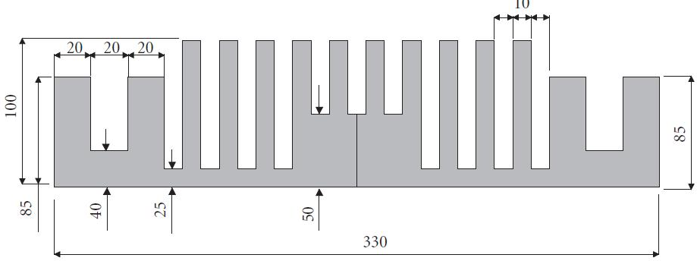

- A furnace with dimensions of its cross-section specified in Figure is constructed from two materials. The inner wall is made of concrete with a thermal conductivity, k_{c} =0.01W/m K. The outer wall is constructed from bricks with a thermal conductivity, k_{b} =0.0057W/m K. The temperature within the furnace is 673 K and the convection heat transfer coefficient h₁
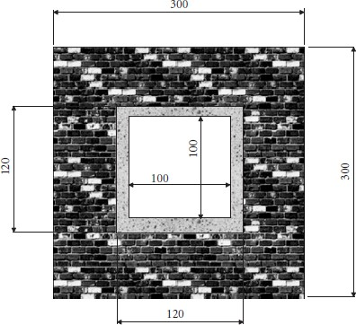
=0.208W/m² K. The outside wall of the furnace is exposed to the surrounding air, which is at 253 K and the corresponding convection heat transfer coefficient, h₂ =0.068W/m² K. Determine the temperature distribution within the concrete and brick walls under steady-state conditions using analysis software. Also determine the heat fluxes through each wall. Take thickness as 2cm.
All Dimensions are in cm.

- Consider the 30 cm long aluminum rod shown in Figure. The rod has a modulus of elasticity E=70 GPa and density ρ= 2700 kg/m³ (self-weight = 5.4 kg/m). The rod is fixed at one end. Find the natural frequencies of the rod using the three-element model using analysis software.
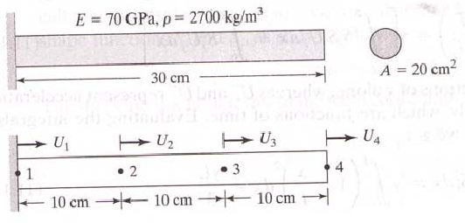

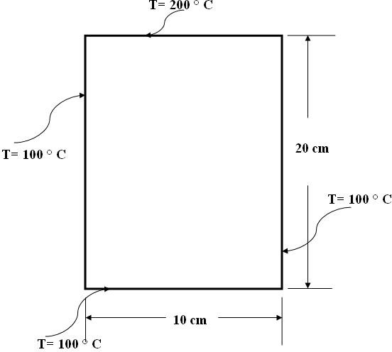
- Plot the temperature distribution of the rectangular plate shown in fig. using analysis software. Thickness of the plate is 1 cm and the thermal conductivity of the plate, K =401 W/(m-K).

