ANNA UNIVERSITY: CHENNAI- 600 025 B.E./B.Tech. DEGREE EXAMINATIONS, Nov./Dec-2020
Regulations-2013 Seventh Semester
B.E. MECHANICAL ENGINEERING

ME6711: SIMULATION AND ANALYSIS LABORATORY

Time: 3 Hours Maximum Marks: 100

- Highlight the stress distribution on plate with circular hole as shown in Figure 1 and obtain the plot for deformed shape and stress distribution for given load and assume suitable boundary condition. Young’s modulus=2x10⁵N/mm²; Poison’s ratio=0.3; Pressure Applied around the inside of the hole=25000N; Material properties: Linear, Elastic, and Isotropic. All dimensions are in ‘mm’. (100)
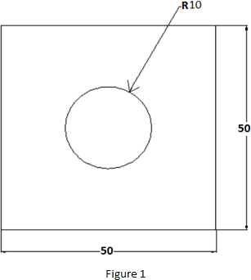

- Analyze the given L-Bracket for stress as shown in Figure 2 and obtain plot for stress distribution and deformed shape by applying suitable boundary condition. E=2x10⁵N/mm², Poisson’s ratio =0.3 Yield stress including safety factor 400 MPa.
Options: Plane Stress; Real Constant: No need to define; Material Properties: Linear, Isotropic. All dimensions are in ‘mm’. (100)

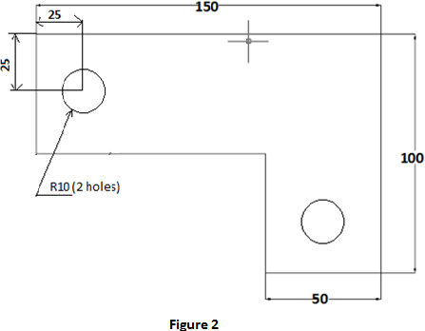

- Obtain the stress distribution of an axisymmetric component shown in Figure 3. The model will be that of a closed tube made from steel. Point load of 50 KN will be applied at the centre of the top and bottom plate. All dimensions are in ‘mm’ (100)

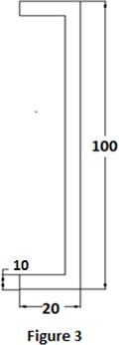

- (a). A distributed load & Point load will be applied to a solid steel beam with a rectangular cross section as shown in the Figure 4(a) below. The cross-section of the beam is 132 mm x 264 mm while the modulus of elasticity of the steel is 210GPa. Find reaction, deflection and stresses in the beam. (50)
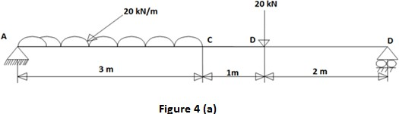
  - (b). Find the various modes of frequencies for the beam shown in Figure 4 (b). Modulus of Elasticity E=206800x10⁶N/m²; Density=7830 kg/m³. All dimensions are in mm.
(50)

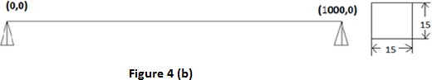

  - (a). A distributed load & Point load will be applied to a solid steel beam with a rectangular cross section as shown in the Figure 5(a). The cross-section of the beam is 150mm x 300mm while the modulus of elasticity of the steel is 210GPa. Find reaction, deflection and stresses in the beam. (50)
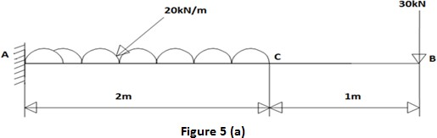

- (b) Find the various modes of frequencies for the beam shown in Figure5(b). Modulus of Elasticity E=206800x10⁶N/m²; Density=7830 kg/m³. All dimensions in mm. (50)

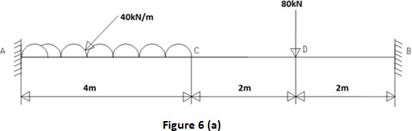
- (a) A distributed load & Point load will be applied to a solid steel beam with a rectangular cross section as shown in the Figure 6(a). The cross-section of the beam is 572 mm x 1144 mm while the modulus of elasticity of the steel is 210GPa. Find reaction, deflection and stresses in the beam. (50)

  - (b) Find the various modes of frequencies for the beam shown in Figure 6(b). Modulus of Elasticity E=206800x10⁶N/m²; Density=7830 kg/m³ (50)
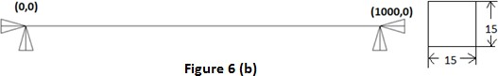

  - Find the various modes of frequencies for the given 2D component shown in Figure 7. All dimensions are in mm. (100)
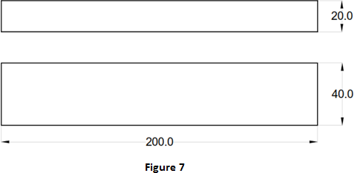

  - Find the various modes of frequencies for the given 2D component in Figure 8. All dimensions are in mm. (100)

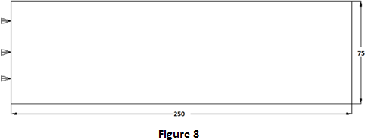

  - (a) Find the various modes of frequencies for the beam shown in Figure 9(a). Modulus of Elasticity E=206800x10⁶N/m²; Density=7830 kg/m³ (50)

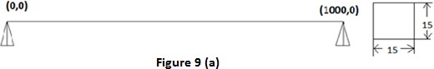

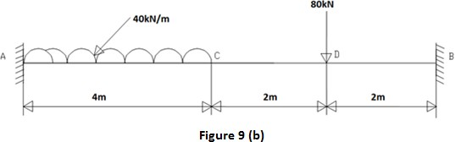
- (b) A distributed load & Point load will be applied to a solid steel beam with a rectangular cross section as shown in the Figure 9(b) below. The cross-section of the beam is 572 mm x 1144 mm while the modulus of elasticity of the steel is 210GPa. Find reaction, deflection and stresses in the beam. (50)

- (a) Find the various modes of frequencies for the beam shown in Figure 10(a). Modulus of Elasticity E=206800x10⁶N/m²; Density=7830 kg/m³ (50)

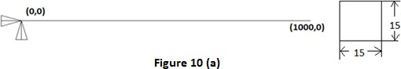

- (b) A distributed load & Point load will be applied to a solid steel beam with a rectangular cross section as shown in the Figure 10(b). The cross-section of the beam is 150mm x 300mm while the modulus of elasticity of the steel is 210GPa. Find reaction, deflection and stresses in the beam. (50)
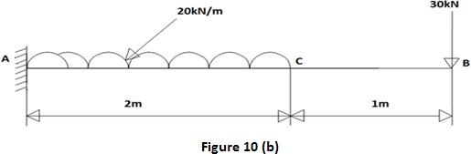

- (a) Find the various modes of frequencies for the beam shown in Figure 11(a). Modulus of Elasticity E=206800x10⁶N/m²; Density=7830 kg/m³ (50)

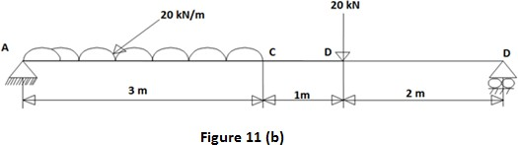
(b) A distributed load & Point load will be applied to a solid steel beam with a rectangular cross section as shown in the Figure 11(b). The cross-section of the beam is 132 mm x 264 mm while the modulus of elasticity of the steel is 210GPa. Find reaction, deflection and stresses in the beam. (50)

- Conduct a harmonic force response analysis on the cantilever beam shown in Figure 12 by applying a cyclic load (harmonic) at the end of the beam. The frequency of load may be varied from1-100 Hz. Modulus of Elasticity E=206800x10⁶N/m²; Density=7830 kg/m³ (100)
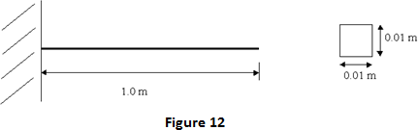

- Perform a conduction analysis for temperature distribution on the block which is constrained as shown in the Figure 13. Thermal conductivity (k) of the material is 10 W/m°C and the block is assumed to be infinitely long. (100)

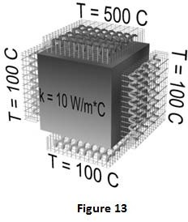

- A steel cooling spine of cross-sectional area A and length L extend from a wall maintained at temperature T_{w} (Figure 14). The surface convection coefficient between the spine and the surrounding air is h, the air temperature is T_{a}, and the tip of the spine is insulated. Apply advanced mesh control with element size of 0.025'. Find the heat conducted by the spine and the temperature of the tip.
Material properties
E= 2.1x10⁵ N/mm²; ν = 0.33; k = 20 W/m K;
Geometric properties
A = 20 x 20 mm²; L = 120 mm
Boundary conditions
T_{w} = 100°T; T_{a} = 30°T; h = 50 W/(m²°K) ( 100)

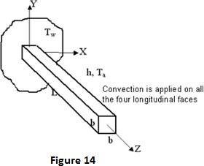

- Analyze the given rectangular plate shown in Figure 15 for temperature distribution. Thermal conductivity of the plate, K_{XX}=401 W/ (m-K) (100)

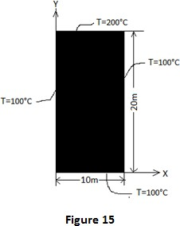

- Perform a simulation of an air conditioning system with condenser and evaporator temperatures as input to get COP using C/MAT Lab. Assume suitable variables.
(100)

- Perform a simulation for the working of a double acting cylinder for any one application using C/MAT Lab. (100)

- Explain the step by step procedure for performing the simulation of cam and follower mechanism as shown in figure. Also perform the simulation using C/MAT Lab.
(100)
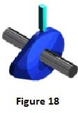

- Analyse the given bracket (Figure 19) built from a 20 mm thick steel plate for deflection and Stress by treating it as plane stress condition. The material is steel. Take E=200 GPa and µ=0.25 (100)
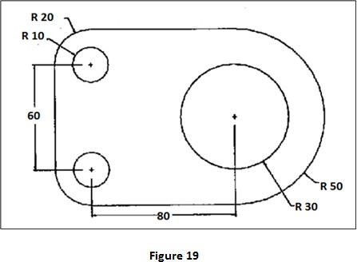

- (a) Analyse the deflection and stresses in the beam shown in Figure 20(a). The cross section of the beam is 500 mm × 1500 mm. Take E=210 GPa. (50)
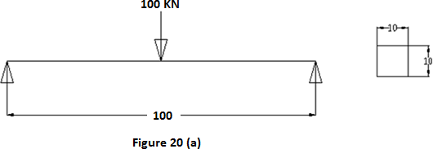
20. (b) Analyse the deflection and stresses in the simply supported beam shown in Figure 20(b). The cross section of the beam is 500 mm × 1500 mm. Take E=210 GPa.
(50)
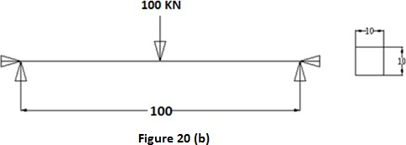

ALLOCATION OF MARKS

ONLINE TEST : 15 MARKS

AIM & PROCEDURE&DESIGN STEPS : 65 MARKS

RESULTS : 10 MARKS

VIVA VOICE : 10 MARKS

TOTAL : 100 MARKS

