SEMBODAI RUKMANI VARATHARAJAN ENGINEERING COLLEGE,SEMBODAI DEPARTMENT OF SCIENCE AND HUMANITIES
CIA-I (Retest)
BRANCH: MECHANICAL DATE: 13 /03/19
SUB: GE 8292 & ENGINEERING MECHANICS YEAR: I/II
MARKS: 50

ANSWER ALL THE QUESTIONS:

PART- A 5X2=10
- State and prove varignon’s theorem.
- Define moment.
- Define principle of transmissibility.
- State lami’s theorem
- What is meant by resultant force?

PART –B 4X10=40

- A string ABCD, attached to two fixed points A and D has two equal weights of 1000N attached to it at B and C. the weights rest with the portions AB and CD inclined at angles of 30⁰ and 60⁰ respectively, to the vertical as shown fig. find the tensions in the portions AB, BC, CD of the string, if the inclination of the portion BC with the vertical is 120⁰.

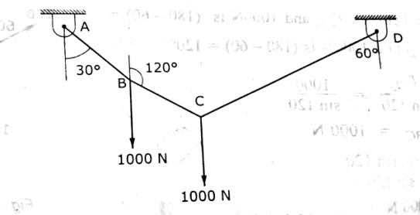

- Two identical rollers, each of weight 50N, are supported by an inclined plane and a vertical wall as shown in fig. find the reactions at the points of supports A, B and C. assume all the surfaces to be smooth.

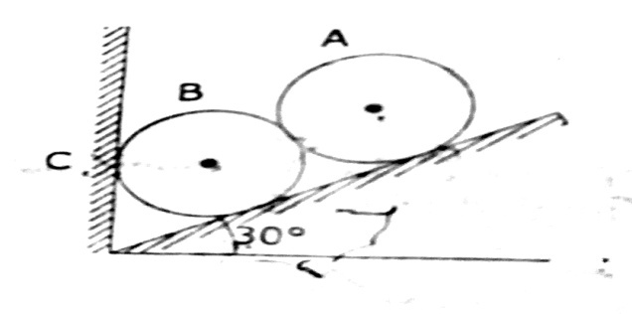

- Two vertical forces and a couple of magnitude 20KNm, acting on a horizontal rod, which is fixed at A. as shown in fig. (i) Determine the resultant of the system (ii) reduce to force couple system at A.

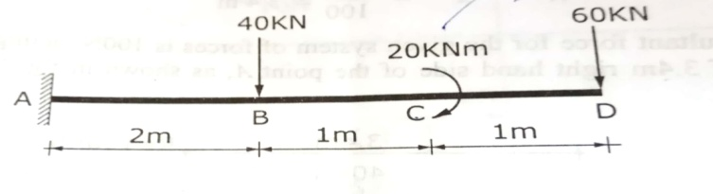

- Find the pin reaction of A and roller reaction at B. for the beam shown in fig.

