

**ANALYSIS AND DEVELOPMENT OF MOTOR**

**AND BATTERY SYSTEM OF AN ELECTRIC VEHICLE**

**A PROJECT REPORT**

***Submitted by***

**R. AJAY (821716114003)**

**V. PALANIVEL (821716114028)**

**D. RANJITH (821716114037)**

**J. ESWARAN (821716114309)**

***In partial fulfillment for the award of the degree***

***of***

**BACHELOR OF ENGINEERING**

**in**

**MECHANICAL ENGINEERING**

**SIR ISSAC NEWTON COLLEGE OF ENGINEERING AND**

**TECHNOLOGY,PAPPAKOVIL,NAGAPATTINAM-611102**

**ANNA UNIVERSITY::CHENNAI 600 025**

**APRIL 2020**

**BONAFIDE CERTIFICATE**

Certificate that this project report **ANALYSIS AND DEVELOPMENT OF‘‘MOTOR AND BATTERY SYSTEM OF AN ELECTRIC VEHICLE**’’ is the bonafide work of

**R. AJAY (821716114003)**

**V. PALANIVEL (821716114028)**

**D. RANJITH (821716114037)**

**J. ESWARAN (821716114310)**

Who carried out the project work under my supervision.

**SIGNATURE SIGNATURE**

**Mr.P.MALAISELVARAJA, M.E., Mr.A.ARULSAKTHI,M.E.,**

**HEAD OF THE DEPARTMENT, SUPERVISOR,**

Department of Mechanical Engineering, Department of Mechanical Engineering

Sir Issac Newton College of Sir Issac Newton College of

Engineering and Technology, Engineering and Technology,

Pappakovil, Nagapattinam-611102 Pappakovil, Nagapattinam-611102

Submitted for the Anna University Viva- Voce Examination held on _________

**INTERNEL EXAMINER** **EXTERNAL EXAMINER**

**ACKNOWLEDGEMENT**

At the outset I think the almighty for his showers of blessings and his divine help which enables me to complete the project successfully. First of all I extend my sincere thanks to **Mr.T.ANANTH., MBA.,**chairman, Sir Isaac Newton College of Engineering and Technology, for offering the means of attending my most cherished goal.

I extend my deepest gratitude to **Dr. G.GIFTSON SAMUEL, M.E., Ph.D.,** principal, Sir Isaac Newton college of Engineering and Technology, for giving permission to do the project work successfully.

It gives immense pleasure to extend my sincere and heartful thanks to our head of the department **Mr.P.MALAISELVARAJA.,M.E.,** Assistant professor, Department of Mechanical Engineering, for his encouragement of appreciation, untiring patience, steadfast ,inspiration and valuable help for the successful completion of the project.

I record my sincere and deep sense of gratitude to my project coordinator **Mr. P. MALAISELVARAJA.,M.E.,** Assistant professor, Department of Mechanical Engineering and to my supervisor, **Mr. A.ARULSAKTHI.,ME.,** Assistant professor, Department of Mechanical Engineering for this guidance and encouragement which has helped me to a lot in completing this project successfully.

I also extend my sincere thanks to staff members of Mechanical Engineering Department.

**ABSTRACT**

This study examined necessary steps needed be achieve the speed and mileage of an electric vehicles (EVs); pure electric vehicles (PEVs). The development of hybrid cars has greatly reduced the emission level of vehicles. However, this is not enough. The purely electrical vehicles are 100% clean and as such their deployment is of great importance. Therefore, these vehicles replace the internal combustion engine in the conventional cars and automobiles with electric motors. Hence, the need for highly improved motors that can perform optimally is of concern for researchers in the field. In this paper, a review of different electric motors with respect to their design simplicity, cost, ruggedness and efficiency is presented. Finally, the brushless DC motor and lithium-ion batteries are proven to be an efficient and most suitable candidate for propulsion drive in electric vehicles. These all happened just for the need for clean energy and the need to cut carbon dioxide emission from internal combustion engines have led researchers and engineers into exploring and developing new drive systems.

Keywords- EVs, PEVs, BLDC Motor, Lithium-ion Batteries, I.C Engines.

**TABLE OF CONTENT**

**CHAPTER NO. TITLE PAGE NO.**

**ABSTRACT iv**

**LIST OF TABLE viii**

**LIST OF FIGURES ix**

**1. INTRODUCTION**

1.1 ELECETRIC VEHICLE 1

1.2 TYPES OF EVs 3

1.2.1 Battery EV’s 3

1.2.2 Plug-in-Hybrid EV’s 4

1.2.3 Hybrid EV’s 5

1.3 HISTORY OF THE EV’s 6

1.4 HOW DO All EV’s WORK 8

1.5 CO2 EMISSION 10

1.6 DISTANCE TO TRAVEL 10

1.7 HOW TO CHARGE 11

1.7.1 Charging stations 11

**2. LITERATURE REVIEW** 14

**CHAPTER NO. TITLE PAGE NO.**

**3. ELECTRIC VEHICLE MOTOR**

3.1 SYNCHRONOUS MOTORS 18

3.1.1 PMSM 18

3.1.2 The Stepper Motor 19

3.1.3 Switched Reluctance Motor 19

3.2 ASYNCHROUNOUS MOTOR 20

3.3 DIRECT CURRENT MOTOR 20

3.3.1 Brushed DC motor 20

3.3.2 Brushless DC motor 21

**4. ANALYSIS OF BATTERY SYSTEM**

4.1 SPECIFICATION OF LI-ION

BATTERY 25

4.2 MODIFICATION OF ELECTRIC

VEHICLE 26

4.3 FUNCTION OF Evs 27

4.3.1 Functions of BEVs 27

**5. ANALYSIS OF BATTERY**

**TEMP IN TERMS OF MOTOR**

5.1 BATTERY LIFE CYCLE 29

5.2 CHARGE RATIO REVIEW 29

5.3 ANALYSIS OF MOTOR REGION 30

**CHAPTER NO. TITLE PAGE NO.**

5.4 ECONOMIC ASPECTS 31

5.5 OPERATION CAPACITY 31

5.6 BMS OF BATTERY 32

**6. ANALYSIS REPORT**

6.1 BATTERY ANALYSIS 33

6.2 MOTOR ANALYSIS 38

**7. ANALYSIS IMAGES OF MOTOR**

**AND BATTERY** 43

**8. CONCLUSION** 50

**9. COST ESTIMATION** 51

**10. BIBLIOGRAPHY** 52

**11. WEBLIOGRAPHY**  53

**LIST OF TABLE**

**TABLES PAGE NO.**

1. **TABLE 1.1 13**
2. **TABLE 6.1 33**
3. **TABLE 6.2 34**
4. **TABLE 6.3 34**
5. **TABLE 6.4 35**
6. **TABLE 6.5 35**
7. **TABLE 6.6 35**
8. **TABLE 6.7 36**
9. **TABLE 6.8 36**
10. **TABLE 6.9 36**
11. **TABLE 6.10 37**
12. **TABLE 6.11 38**
13. **TABLE 6.12 38**
14. **TABLE 6.13 39**
15. **TABLE 6.14 39**
16. **TABLE 6.15 40**
17. **TABLE 6.16 40**
18. **TABLE 6.17 40**
19. **TABLE 6.18 41**
20. **TABLE 6.19 41**
21. **TABLE 6.20 42**
22. **TABLE 9.1 52**

**LIST OF FIGURES**

1. Fig.1.1 Block diagram of electric vehicle 2
2. Fig.1.2 EDISON 1914 [Detroit Electric](https://en.m.wikipedia.org/wiki/Detroit_Electric) model 47 6
3. Fig.1.3 Model of an electric vehicle 8
4. Fig.1.4 Average daily drive in BC’s urban regions 11
5. Fig.1.5 Public Charging Stations in BC 12
6. Fig.3.1 Classes of Electric Motors 18
7. Fig.3.2 Brushless DC motor 22
8. Fig.4.1 Li-ion battery roadmap 23
9. Fig.6.1 Analysis of Battery 33
10. Fig 6.2 BLDC motor 38
11. Ansys fig.7.1 43
12. Ansys fig.7.2 44
13. Ansys fig.7.3 44
14. Ansys fig.7.4 45
15. Ansys fig.7.5 45
16. Ansys fig.7.6 46
17. Ansys fig.7.7 46
18. Ansys fig.7.8 47
19. Ansys fig.7.9 47
20. Ansys fig.7.10 48
21. Ansys fig.7.11 48
22. Ansys fig.7.12 49
23. Ansys fig.7.13 49
24. Ansys fig.7.14 50

**CHAPTER-1**

**INTRODUCTION**

Electric Vehicles (EVs) have been revived since the late 1990s due to environmental causes and breakthroughs in battery technology. As a result, the EV markets in developed nations evolved to compete with conventional combustion engine vehicles. However, there is a need to reduce the global carbon emissions, which recently crossed the 400 ppm threshold permanently. EVs are proposed as a realistic solution and a necessity to mitigate the effects of global warming. This solution should be expanded to highly populated developing countries that contribute to over 63 percent of the global emissions to develop a zero carbon transport infrastructure. This application for sustainable transportation is best suited for developing nations like India which already has a potential EV market for two wheel, three wheel vehicles and buses. This paper discusses the various factors required to establish a thriving EV market in India while accounting for challenges that are unique to the nation to promote EV as an alternative e-mobility transport option for the masses thereby addressing the energy inequality crisis.

**1.1 WHAT IS ELECTRIC VEHICLE**

An electric vehicle (EV) is one that operates on an electric motor, instead of an internal-combustion engine that generates power by burning a mix of fuel and gases. Therefore, such as vehicle is seen as a possible replacement for current-generation automobile, in order to address the issue of rising pollution, global warming, depleting natural resources, etc. Though the concept of electric vehicles has been around for a long time, it has drawn a considerable amount of interest in the past decade amid a rising carbon footprint and other environmental impacts of fuel-based vehicles.

In India, the first concrete decision to incentivize electric vehicles was taken in 2010. According to a Rs 95-crore scheme approved by the Ministry of New and Renewable Energy (MNRE), the government announced a financial incentive for manufacturers for electric vehicles sold in India. The scheme, effective from November 2010, envisaged incentives of up to 20 per cent on ex-factory prices of vehicles, subject to a maximum limit. However, the subsidy scheme was later withdrawn by the MNRE in March 2012.

In 2013, India unveiled the 'National Electric Mobility Mission Plan (NEMMP) 2020' to make a major shift to electric vehicles and to address the issues of national energy security, vehicular pollution and growth of domestic manufacturing capabilities. Though the scheme was to offer subsidies and create supporting infrastructure for e-vehicles, the plan mostly remained on papers. While presenting the Union Budget for 2015-16 in Parliament, then finance minister Arun Jaitley announced faster adoption and manufacturing of electric vehicles (FAME), with an initial outlay of Rs 75 crore. The scheme was announced with an aim to offer incentives for clean-fuel technology cars to boost their sales to up to 7 million vehicles by 2020.



Fig.1.1 BLOCK DIAGRAM OF ELECTRIC VEHICLE

In 2017, Transport Minister Nitin Gadkari made a statement showing India’s intent to move to 100 per cent electric cars by 2030. However, the automobile industry raised concerns over the execution of such a plan. The government subsequently diluted the plan from 100 per cent to 30 per cent.In February 2019, the Union Cabinet cleared a Rs 10,000-crore programme under the FAME-II scheme. This scheme came into force from April 1, 2019. The main objective of the scheme is to encourage a faster adoption of electric and hybrid vehicles by offering upfront incentives on purchase of electric vehicles and also by establishing necessary charging infrastructure for EVs.

### 1.2 TYPES OF ELECTRIC VEHICLE: BEV, PHEV AND HEV

There are three main types of electric vehicles (EVs), classed by the degree that electricity is used as their energy source. BEVs, or battery electric vehicles, PHEVs of plug-in hybrid electric vehicles, and HEVs, or hybrid electric vehicles. Only BEVs are capable of charging on a level 3, DC fast charge.

**1.2.1 Battery Electric Vehicles (BEV)**

Battery Electric Vehicles, also called BEVs, and more frequently called EVs, are fully-electric vehicles with rechargeable batteries and no gasoline engine. Battery electric vehicles store electricity onboard with high-capacity battery packs. Their battery power is used to run the electric motor and all onboard electronics. BEVs do not emit any harmful emissions and hazards caused by traditional gasoline-powered vehicles. BEVs are charged by electricity from an external source. Electric Vehicle (EV) chargers are classified according to the speed with which they recharge a EVs battery.

The classifications are Level 1, Level 2, and Level 3 or DC fast charging. Level 1 EV charging uses a standard household (120v) outlet to plug into the electric vehicle and takes over 8 hours to charge an EV for approximately 75-80 miles. Level 1charging is typically done at home or at your workplace. Level 1 chargers have the capability to charge most EVs on the market.

Level 2 charging requires a specialized station which provides power at 240v. Level 2 chargers are typically found at workplaces and public charging stations and will take about 4 hours to charge a battery to 75-80 miles of range.

Level 3 charging, DC fast charging, or simply fast charging is currently the fastest charging solution in the EV market. DC fast chargers are found at dedicated EV charging stations and charge a battery up to 90 miles range in approximately 30 minutes.

**BEV** Examples that can charge on DC Level 3 Fast Chargers

* Tesla Model 3
* BMW i3
* Chevy Bolt
* Chevy Spark
* Nissan LEAF
* Ford Focus Electric
* Hyundai Ioniq
* Karma Revera
* Kia Soul
* Mitsubishi i-MiEV
* Tesla Model S
* Tesla X
* Toyota Rav4
* Volkswagen e-Golf

* + 1. **Plug-in Hybrid Electric Vehicle (PHEV)**

Plug-in Hybrid Electric Vehicles or PHEVs can recharge the battery through both regenerative braking and “plugging in” to an external source of electrical power. While “standard” hybrids can (at low speed) go about 1-2 miles before the gasoline engine turns on, PHEV models can go anywhere from 10-40 miles before their gas engines provide assistance.

**PHEV** Examples

* Chevy Volt
* Chrysler Pacifica
* Ford C-Max Energi
* Ford Fusion Energi
* Mercedes C350e
* Mercedes S550e
* Mercedes GLE550e
* Mini Cooper SE Countryman
* Audi A3 E-Tron
* BMW 330e
* BMW i8
* BMW X5 xdrive40e
* Fiat 500e
* Hyundai Sonata
* Kia Optima
* Porsche Cayenne S E-Hybrid
* Porsche Panamera S E-hybrid
* Toyota Prius
* Volvo XC90 T8

**1.2.3 Hybrid Electric Vehicles (HEV)**

HEVs are powered by both gasoline and electricity. The electric energy is generated by the car’s own braking system to recharge the battery. This is called ‘regenerative braking’, a process where the electric motor helps to slow the vehicle and uses some of the energy normally converted to heat by the brakes.

HEVs start off using the electric motor, then the gasoline engine cuts in as load or speed rises. The two motors are controlled by an internal computer, which ensures the best economy for the driving conditions.

**HEV** Examples

* Toyota Prius Hybrid
* Honda Civic Hybrid
* Toyota Camry Hybrid

**1.3** [History of the electric vehicle](https://en.m.wikipedia.org/wiki/History_of_the_electric_vehicle)

Electric motive power started in 1827, when Hungarian priest [Anyos Jedlik](https://en.m.wikipedia.org/wiki/%C3%81nyos_Jedlik) built the first crude but viable electric motor, provided with stator, rotor and commutator, and the year after he used it to power a tiny car. A few years later, in 1835, professor Sibrandus Stratingh of the University of Groningen, the Netherlands, built a small-scale electric car, and between 1832 and 1839 (the exact year is uncertain), [Robert Anderson](https://en.m.wikipedia.org/wiki/Robert_Anderson_(inventor)) of [Scotland](https://en.m.wikipedia.org/wiki/Scotland) invented the first crude electric carriage, powered by non-rechargeable [primary cells](https://en.m.wikipedia.org/wiki/Primary_cell).

**[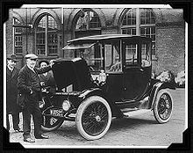](https://en.m.wikipedia.org/wiki/File:EdisonElectricCar1913.jpg)**

Fig.1.2 EDISON 1914 [Detroit Electric](https://en.m.wikipedia.org/wiki/Detroit_Electric) model 47

Around the same period, early experimental electrical cars were moving on rails, too. American blacksmith and inventor [Thomas Davenport](https://en.m.wikipedia.org/wiki/Thomas_Davenport_(inventor)) built a toy electric locomotive, powered by a primitive electric motor, in 1835. In 1838, a Scotsman named [Robert Davidson](https://en.m.wikipedia.org/wiki/Robert_Davidson_(inventor)) built an electric locomotive that attained a speed of four miles per hour (6 km/h). In England a patent was granted in 1840 for the use of rails as conductors of electric current, and similar American patents were issued to Lilley and Colten in 1847.

The first mass-produced electric vehicles appeared in America in the early 1900s. In 1902, "Studebaker Automobile Company" entered the automotive business with electric vehicles, though it also entered the gasoline vehicles market in 1904. However, with the advent of cheap assembly line cars by Ford, electric cars fell to the wayside.

Due to the limitations of [storage batteries](https://en.m.wikipedia.org/wiki/Storage_batteries) at that time, electric cars did not gain much popularity, however electric trains gained immense popularity due to their economies and fast speeds achievable. By the 20th century, electric rail transport became commonplace due to advances in the development of [electric locomotives](https://en.m.wikipedia.org/wiki/Electric_locomotives). Over time their general-purpose commercial use reduced to specialist roles, as [platform trucks](https://en.m.wikipedia.org/wiki/Electric_platform_truck), [forklift trucks](https://en.m.wikipedia.org/wiki/Forklift_truck), ambulances, tow tractors and urban delivery vehicles, such as the iconic British [milk float](https://en.m.wikipedia.org/wiki/Milk_float); for most of the 20th century, the UK was the world's largest user of electric road vehicles.

Electrified trains were used for coal transport, as the motors did not use precious [oxygen](https://en.m.wikipedia.org/wiki/Oxygen) in the mines. Switzerland's lack of natural fossil resources forced the rapid electrification of [their rail network](https://en.m.wikipedia.org/wiki/Rail_transport_in_Switzerland). One of the earliest [rechargeable batteries](https://en.m.wikipedia.org/wiki/Rechargeable_batteries) – the [nickel-iron battery](https://en.m.wikipedia.org/wiki/Nickel-iron_battery) – was favoured by [Edison](https://en.m.wikipedia.org/wiki/Thomas_Edison) for use in electric cars.

EVs were among the earliest automobiles, and before the pre-eminence of light, powerful [internal combustion engines](https://en.m.wikipedia.org/wiki/Internal_combustion_engines), electric automobiles held many vehicle land speed and distance records in the early 1900s. They were produced by [Baker Electric](https://en.m.wikipedia.org/wiki/Baker_Electric), [Columbia Electric](https://en.m.wikipedia.org/wiki/Columbia_Automobile_Company), [Detroit Electric](https://en.m.wikipedia.org/wiki/Detroit_Electric), and others, and at one point in history out-sold gasoline-powered vehicles. In fact, in 1900, 28 percent of the cars on the road in the USA were electric. EVs were so popular that even President [Woodrow Wilson](https://en.m.wikipedia.org/wiki/Woodrow_Wilson) and his secret service agents toured Washington, DC, in their Milburn Electrics, which covered 60–70 mi (100–110 km) per charge.

A number of developments contributed to decline of electric cars. Improved required a greater range than that offered by electric cars, and the discovery of large reserves of petroleum in Texas, Oklahoma, and California led to the wide availability of affordable gasoline/petrol, making internal combustion powered cars cheaper to operate over long distances. Also internal combustion powered cars became ever easier to operate thanks to the invention of the [electric starter](https://en.m.wikipedia.org/wiki/Electric_starter) by [Charles Kettering](https://en.m.wikipedia.org/wiki/Charles_Kettering) in 1912, which eliminated the need of a hand crank for starting a gasoline engine, and the noise emitted by ICE cars became more bearable thanks to the use of the [muffler](https://en.m.wikipedia.org/wiki/Muffler), which [Hiram Percy Maxim](https://en.m.wikipedia.org/wiki/Hiram_Percy_Maxim) had invented in 1897. As roads were improved outside urban areas electric vehicle range could not compete with the ICE. Finally, [the initiation of mass production](https://en.m.wikipedia.org/wiki/Assembly_line) of gasoline-powered vehicles by [Henry Ford](https://en.m.wikipedia.org/wiki/Henry_Ford) in 1913 reduced significantly the cost of gasoline cars as compared to electric cars.

In the 1930s, [National City Lines](https://en.m.wikipedia.org/wiki/National_City_Lines), which was a partnership of [General Motors](https://en.m.wikipedia.org/wiki/General_Motors), [Firestone](https://en.m.wikipedia.org/wiki/Firestone_Tire_and_Rubber_Company), and [Standard Oil of California](https://en.m.wikipedia.org/wiki/Standard_Oil_of_California) purchased many electric tram networks across the country to dismantle them and replace them with GM buses. The partnership was convicted of [conspiring](https://en.m.wikipedia.org/wiki/General_Motors_streetcar_conspiracy) to monopolize the sale of equipment and supplies to their subsidiary companies, but were acquitted of conspiring to monopolize the provision of transportation services.

# 1.4 How Do All-Electric Cars Work?

All-electric vehicles (EVs) have an electric motor instead of an internal combustion engine. The vehicle uses a large traction battery pack to power the electric motor and must be plugged in to a [charging station](https://afdc.energy.gov/fuels/electricity_infrastructure.html) or wall outlet to charge. Because it runs on electricity, the vehicle emits no exhaust from a tailpipe and does not contain the typical liquid fuel components, such as a fuel pump, fuel line, or fuel tank.

[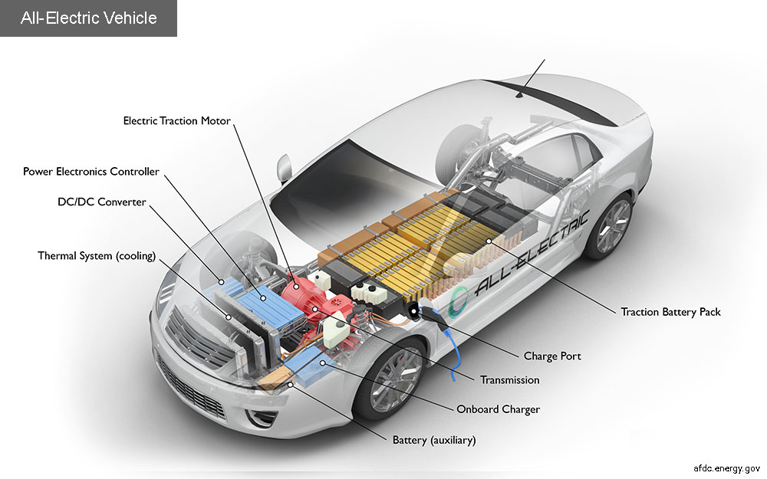](https://afdc.energy.gov/sp/assets/car_pages/electric-c6dddcfed973673ca0cc28eddfcb3e385d56b94e8c33d7120aa3f125609e8249.jpg)

Fig.1.3 Model of an electric vehicle

## Key Components of an All-Electric Car

**Battery (all-electric auxiliary):** In an electric drive vehicle, the auxiliary battery provides electricity to power vehicle accessories.

**Charge port:** The charge port allows the vehicle to connect to an external power supply in order to charge the traction battery pack.

**DC/DC converter:** This device converts higher-voltage DC power from the traction battery pack to the lower-voltage DC power needed to run vehicle accessories and recharge the auxiliary battery.

**Electric traction motor:** Using power from the traction battery pack, this motor drives the vehicle's wheels. Some vehicles use motor generators that perform both the drive and regeneration functions.

**Onboard charger:** Takes the incoming AC electricity supplied via the charge port and converts it to DC power for charging the traction battery. It monitors battery characteristics such as voltage, current, temperature, and state of charge while charging the pack.

**Power electronics controller:** This unit manages the flow of electrical energy delivered by the traction battery, controlling the speed of the electric traction motor and the torque it produces.

**Thermal system (cooling):** This system maintains a proper operating temperature range of the engine, electric motor, power electronics, and other components.

**Traction battery pack:** Stores electricity for use by the electric traction motor.

**Transmission (electric):** The transmission transfers mechanical power from the electric traction motor to drive the wheels.

### 1.5 How does an Electric Car Work - **CO2 emission free Malta**

Look exactly like fossil fuel-powered cars. An electric car lacks a tailpipe and gas tank, but the overall structure is basically the same. Under the bonnet, instead of a huge engine all you will see is an electric motor and its controller. The electric motor needs no oil, no tune-ups, and since there is no tailpipe emission, it does not necessitate any smog checks.

The electric vehicle power source is the battery which acts as a "gas tank" and supplies the electric motor with the energy necessary to move the vehicle.  This gives the car acceleration.  When the vehicle is idle there is no electrical current being processed, so energy is not being used up. The controller acts as a regulator, and controls the amount of power received from the batteries so the motor does not burn out. This battery powers all of the electronic devices in the car, just like the battery in a gas-powered car. Everything else in the electric car is basically the same as its gas-powered equivalent: transmission, brakes, air conditioning, and airbags. Since electric vehicles use an electric motor, the driver can take advantage of the motor's momentum when pressure is applied on the brakes.  Instead of converting all the potential energy in the motor into heat like a fossil fuel-powered car does, an electric car uses the forward momentum of the motor to recharge the battery. This process is called regenerative braking.

**1.6 How far can I drive before I have to recharge**

The first question many ask is how far an Electric Vehicle travel before it needs to be recharged. Firstly, when was the last time you ran out of gas in your vehicle?? For most people the answer is never, because they watch the fuel gauge and fill up their tank when it is almost empty. It’s the same with an EV, you can pull into one of the 450 public charging stations to “top up” or plug your car in each night at home just like you do with your cell phone and always leave home with a full battery. The average daily drive in BC’s urban regions is 30km and all electric vehicles today can drive at least 100km’s before needing to be recharged which is illustrated on the map.

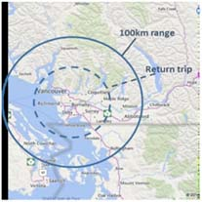

Fig.1.4 Average daily drive in BC’s urban regions

If you need more there are some BEVs that can drive up to 426km or you could look at a hybrid vehicle which also has a gasoline engine that can be used once the battery runs out.

**1.7 How do you charge your EV?**

Now that you have chosen the EV that best fits your needs, how do you charge it up? Well it’s as easy as charging your phone and can be done in the comfort of your home or at the 500+ public charging stations in BC plus more in the US.

* It’s easy to charge every night they so EV drivers don’t need as much one-time range as a typical gas-engine car driver who may refuel once a week or once a month.
* When you charge at home you can always leave with a full battery.
* With more than 500 EV charging stations in BC there is a good chance you can charge your EV while you are at work, shopping, at the movies, at the mall, at the doctor or dentist, etc so you can probably drive further than you think.

EV’s will also charge themselves whenever you brake or go downhill so sometimes you will have more range available at the bottom of the hill than you did at the top.

**1.7.1 Public Charging Stations in BC**

With over 500+ public charging stations there is bound to be somewhere you can top up while you are shopping, going to the movies, at work, grabbing a bite to eat. You can see from the map below courtesy of www.PlugShare.com that there are plenty of places for you to be able to charge while on the go plus give you the ability to do some super fun road trips!



Fig.1.5 Public Charging Stations in BC

There are a couple of different types of charges each with different times it takes to charge your EV, the table below provides more details.

|  |  |  |
| --- | --- | --- |
| Level 1 – Trickle Charge | **Untitled-1 copy** | 1. You can plug your EV into any normal 110v plug just like you do to charge your phone.  2. This will add 8km of range to your EV per hour.  3. The charging cable will come with your EV. |
| Level 2 –Charge @ Home | **Untitled-1 copy** | 1.You can purchase a 220v charging station for your home for approximately $500  2. A certified electrician will need to install this.  3. These chargers will add 42km of range per hour or typically take 3-4 hours for a full charge. |
| Level 2 – Public Charging Station | **Untitled-1 copy** | There are 500+ public charging stations in BC and many are free of charge.  1. Find charge stations in your area using www.plugshare.com  2. These chargers will add 25km+ of range per hour or typically take approx. 4 hours for a full charge. |
| Level 3- FAST Charge  (High Power Stations) | **Untitled-1 copy** | 1. Adds 136km of range to your EV in 30min!  2.There are a number of Fast Chargers in BC  3.You EV needs to be equipped to support a Fast Charger |

TABLE .1.1

**CHAPTER-2**

**LITERATURE SURVEY**

By  **Paul Wolfram and**[**Nic Lutsey**](mailto:nic@theicct.org)

The paper aims to inform the debate over how electric vehicle technology could fit into a lower-carbon 2020–2030 new vehicle fleet in Europe by collecting, analyzing, and aggregating the available research literature on the underlying technology costs and carbon emissions. It concentrates on the three electric propulsion systems: battery electric vehicles (BEVs), plug-in hybrid electric vehicles (PHEVs), and hydrogen fuel cell electric vehicles (HFCEVs). The author’s project that the costs of all will decrease significantly between 2015 and 2030: PHEVs will achieve about a 50% cost reduction, compared with approximate cost reductions of 60% for BEVs and 70% for HFCEVs.

Greenhouse gas (GHG) emissions and energy demand for electric and conventional vehicles are presented on a well-to-wheel (WTW) basis, capturing all direct and indirect emissions of fuel and electricity production and vehicle operation. The authors find that carbon emissions of BEVs using European grid-mix electricity are about half of average European vehicle emissions, with HFCEVs and PHEVs having a lower emissions reduction potential. A lower-carbon grid and higher power train efficiency by 2020 could cut average electric vehicle emissions by another third. However, reductions in costs and CO2 emission will not be achieved without targeted policy intervention. More stringent CO2 standards, as well as fiscal and non-fiscal incentives for electric vehicles, can help the electric vehicle market grow and costs fall. Such efforts should also be combined with efforts to decarbonizes the grid, or emission reductions will not be as great as they could be.

Although the analysis is focused on Europe, similar technology, policy, and market dynamics can be observed in electric-vehicle markets throughout North America and Asia.

By **[Rajeev Ranjan and](https://www.sciencedirect.com/science/article/abs/pii/S095965261934781X" \l "!)** [**KumarAlok**](https://www.sciencedirect.com/science/article/abs/pii/S095965261934781X#!)

Scholarly research on the topic of electric vehicles has witnessed a dramatic increase in the current decade; however, reviews that synthesize and integrate these findings comprehensively have been lacking. This study is an attempt at filling in that void through an integrative review methodology. It includes an integrative review of 239 articles published across Scopus Q1 journals and compiled using an integrative review protocol. It encompasses the identification of variables in five different categories: antecedents, mediators, moderators, consequences, and socio-demographics. The analysis procedure revealed many interesting insights related to research methods and region-specific developments. The review draws attention to relatively neglected topics such as dealership experience, charging infrastructure resilience, and marketing strategies as well as identifies much-studied topics such as charging infrastructure development, total cost of ownership, and purchase-based incentive policies. It also clarifies the mechanisms of electric vehicle adoption by highlighting important mediators and moderators. The findings would be beneficial to both researchers and policymakers alike, as there has been a dearth of earlier reviews that have analyzed all sustainable consequence variables simultaneously and collectively. The development of a comprehensive nomological network of electric vehicle adoption added a new dimension in this study. The segment-wise key policy recommendations provide many insights for stakeholders to envisage electric mobility.

By [**Eric Molin**](https://www.tandfonline.com/author/Molin%2C+Eric) **and** [**Bert van Wee**](https://www.tandfonline.com/author/van+Wee%2C+Bert)

Widespread adoption of electric vehicles (EVs) may contribute to the alleviation of problems such as environmental pollution, global warming and oil dependency. However, the current market penetration of EV is relatively low in spite of many governments implementing strong promotion policies. This paper presents a comprehensive review of studies on consumer preferences for EV, aiming to better inform policy-makers and give direction to further research. First, we compare the economic and psychological approach towards this topic, followed by a conceptual framework of EV preferences which is then implemented to organise our review. We also briefly review the modelling techniques applied in the selected studies. Estimates of consumer preferences for financial, technical, infrastructure and policy attributes are then reviewed. A categorisation of influential factors for consumer preferences into groups such as socio-economic variables, psychological factors, mobility condition, social influence, etc. is then made and their effects are elaborated. Finally, we discuss a research agenda to improve EV consumer preference studies and give recommendations for further research.

**CHAPTER-3**

**ELECTRIC VEHICLE MOTOR**

An electric vehicle consists of three major subsystems; the energy source subsystem, the auxiliary subsystem and the electric propulsion subsystem. The electronic propulsion subsystem comprises of electronic controller, the power converter, the mechanical transmission and the electric motor. In this work, a review of different motors available as propulsion for electric vehicle is presented. The development of electrical drives dates back to the 18th century when Faraday demonstrated the principle of the electromagnetic induction. Following the invention of faraday’s law, electric motors were invented and that bred the two major classes of motors; Alternating Current and Direct Current motors.

Typically, an electric motor consists of a rotor, stator, windings, air gap and commutators/converters. Depending on different arrangement of these components different types of electric motors are constructed. Those electric motors that do not require brushes for commutation or energy conversion are called brushless permanent magnet motors. Furthermore, motors can be categorized according to the shape of their back-EMF. Their shape can either be sinusoidal or trapezoidal. Based on these shapes, they can be Permanent Magnet AC Synchronous Motors (PMSM) or Brushless DC motors (BLDC) respectively.

For an Electric motor to be successfully deployed as the drive for EVs it should be highly efficient, it should have great power density and should be cost-effective. However, the specification of the motors depends on its application purpose. This application could range from home, regular vehicular and heavy duty vehicles. Furthermore, the performance of motors depends mainly on vehicle duty cycle, thermal characteristics and the cooling mechanism implemented. The classification of various motors used in traction is shown in Figure 1. A brief literature review on the motors used for traction in EV/HEVs is presented below. In this work, literature review of both AC motors and DC motors is presented looking at the features mentioned earlier.



Fig.3.1 Classes of Electric Motors

## 3.1 SYNCHRONOUS MOTORS

Synchronous motors are motors where the shaft of the rotor is synchronized with the frequency of the supply current. In these motors the period of the rotor is exactly same as that of the supply.

**3.1.1 Permanent Magnet Synchronous Motor (PMSM)**

This motor shares some similarities with the BLDC motor, but is driven by a sinusoidal signal to achieve lower torque ripple. The sinusoidal distribution of the multi-phase stator windings generates a sinusoidal flux density in the air gap that is different from BLDC motor’s trapezoidal flux density. This motor possesses feature of an induction motor and a brushless dc motor. The motor has a permanent magnet rotor and winding on its stator. Furthermore, the stator of this motor is designed to produce sinusoidal flux density which resembles that of an induction motor. The power density of this motor is higher than induction motors with the same ratings since there is no stator power dedicated to magnetic field production. Today, these motors are designed to be more powerful while also having a lower mass and lower moment of inertia. This motor can generate torque at zero speed, highly efficient and produces high power density compared to an induction motor. However, this motor requires a drive to operate.

To achieve the specifications of high torque at low speed, high density and high efficiency, this motor uses variable frequency drive. However, the VFD control technique increases the complexity of the system and hence requires careful attention to precisely control its speed. Hence the cost of this motor is on the higher side as compared to the induction motor

**3.1.2 The Stepper Motor**

The stepper motor and switched reluctance motor have the same structure. The stator of a stepper motor consists of concentrated winding coils, while the rotor is made of soft iron laminates without coils. Torque is produced in these motors when the current switches from one set of stator coil to the next coil, the switching currents from stator windings generates magnetic attraction between rotor and stator to rotate the rotor to the next stable position, or "step". The rotational speed is determined by the frequency of the current pulse, and the rotational distance is determined by the number of pulses. Since each step results in a small displacement, a stepper motor is typically limited to low-speed position-control applications. The ability to move a specific step makes these devices commonly used in positioning mechanisms. Stepper motors are characterized by their moving and holding torque which if exceeded the motor slips and hence the motor loses count. This motor produces torque through magnetic reluctance, magnetic attraction or both. The motor doesn’t offer dynamic speed control. The motor can only be accelerated at full toque to full speed and decelerates at full torque. Hence, the motor offers greater torque for a given speed. Therefore, this motor is ideal for precision and position control purposes, making it unsuitable for EV application.

**3.1.3 The Switched Reluctance Motor**

The rotor in the Switched Reluctance motor (SR) cannot generate magnetic field around itself because of the absence of coils in the rotor, therefore no reactive torque is produced in an SR motor. Torque in these motors is produced when a stator phase is energized; the stator pole pair attracts the closest rotor pole pair toward alignment of the poles. This way, high-torque ripple is generated which contributes to acoustic noise and vibration. However, due to its simple design, SR motor is very economical to build, and is perhaps the most robust motor available. This motor relatively produces lower torque compared with the stepper motor. Hence, its use is not popular in EV application.

## 3.2 Asynchrounous Motor (Induction Motor)

In this motor, the current in rotor winding is obtained from the field of the stator winding by electromagnetic induction. The rotor current is now utilized for torque production. The popular asynchronous motor available is the induction motor. In this motor, a sinusoidal AC current is used to excite the stator to create a rotating magnetic field that induces a current in the rotor; the induced current in the rotor generate a relative magnetic field in the rotor. The magnetic fields in the rotor and the stator run at slightly different frequencies and hence generate torque. The induction motors are characterized with cheaper cost, absence of brushes, commutators and low maintenance. These features make the induction motor attractive in EVs. However, the need for converting the power supply from AC to DC demands more circuitry and hence complex control schemes.

**3.3 Direct Current Motors**

In this section, the different DC motors available is presented. Motors such as brushed DC and the Brushless DC are presented in terms of their respective power density, efficiency and cost.

## 1. Brushed DC motor

## 2. Brushless DC motor

**3.3.1 Brushed DC motor**

A brushed DC motor consists of a commutator and brushes that convert a DC current in an armature coil to an AC current. As current flows through the armature windings, the electromagnetic field repels the nearby magnets with the same polarity, and causes the winging to turn to the attracting magnets of opposite polarity. As the armature turns, the commutator reverses the current in the armature coil to repel the nearby magnets, thus causing the motor to continuously turn. This motor can be driven by DC power, hence it is very attractive for low-cost applications. However, some drawbacks of brushed DC motor are the arcing produced by the armature coils on the brush-commutator surface generating heat, wear, and electromagnetic interference (EMI).These characteristics of the brushed motor indicate that it is more suitable in applications where high efficiency is not a major concern. This renders use of this type of motor less attractive in EV applications.

**3.3.2 Brushless DC motor**

The brushless DC (BLDC) motors are the most popular and widely used in control application and are configured into single-phase, 2-phase and 3-phase. The simple structure, ruggedness, and low-cost of a BLDC motor make it a viable candidate for various general purpose applications. The BLDC combined with a suitable controlled converter provides several desired characteristics for an efficient drive system. One major advantage of BLDC is enhanced speed versus torque characteristics as compared with other electric motors. Furthermore, the BLDC accomplishes commutation electronically using rotor position feedback to determine when to switch the current. This motor is built with a permanent magnet rotor and wire-wound stator poles. The rotor is formed from permanent magnet and can alter from two-pole to eight-pole pairs with alternate North (N) and South (S) poles. The stator windings work with the permanent magnets on the rotor to generate a uniform flux density in the air gap. This permits the stator coils to be driven by a constant DC voltage (hence the name brushless DC). The rotor position of a BLDC sensed using Hall Effect sensors is very important; this gives the information about winding that is energized at the moment and the winding that will be energized in sequence. Whenever the rotor magnetic poles pass near the hall sensors, they give a high or low signal, suggesting the N or S pole is passing near the sensors. The exact order of commutation can be estimated, depending upon the combination of these three hall sensor signals.

Furthermore, Sensor less control strategies can be used to eliminate the position sensors, thus reducing the cost and size of motor. In fact, control methods, such as back-EMF and current sensing can provides enough information to estimate with sufficient precision the rotor position and, therefore, to operate the motor with synchronous phase currents. Perhaps, the most popular BEMF methods rely on one technique called the zero crossing point (ZCP), being the only point to provide the rotor position information at either 00 or 1800 electrical. The zero crossing point methods are succeeded by a phase shift of 300 or 900 to match the commutation instances. Any detection error of the ZCP results in a sub-optimal phase current.A conceptual method which uses extended kalman filter for estimating the exact commutation instance of a winding is suggested. This method shall be further developed, validated and reported.

The BLDC motor offers excellent power density as compared to other motors, higher torque, reduced operational and mechanical noise, elimination of electromagnetic interference and offers excellent efficiency. Hence, this motor is the most popular in EV

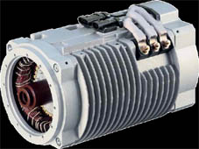

**Fig.3.2 Brushless DC motor**

**CHAPTER-4**

**ANALYSIS OF BATTERY SYSTEM**

Nowadays, electric vehicles (EVs) are booming, due to the existing environmental problems. Among the different storage technologies in electromobility, batteries stand out the most. Although there are other alternatives such as hydrogen storage, a battery is also required for DC bus voltage stabilization and switching on of other essential or auxiliary devices of the fuel cell system. High capital costs, limited lifetime, and relatively poor performance at low temperatures are the most important issues in EVs. Therefore, the development of efficient storage technologies is an essential part for electromobility.

Lithium technology is highlighted for electromobility among the studied batteries options. Its specific power and energy density are the highest, with the lowest self-discharge ratio. In addition, voltage by cell is higher, which is the major drawback of the low overcharging tolerance. Therefore, a specifically designed charging system is required for this type of battery.Lithium is the material basis of this type of battery, since lithium ions are carried from cathode to anode (charging) through a separator, and vice versa (discharging). However, lithium-ion (Li-Ion) batteries can be classified among different categories based on other elements, mainly those corresponding corresponding to the cathode chemical composition. Figure 1 shows a comparative summary of the best-known lithium.

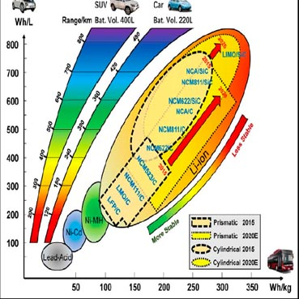

Fig.4.1 LI-ION BATTERY ROADMAP

The average lifetime of batteries in EVs tends to be approximately 8 to 10 years, which is defined by 20–30% degradation in battery capacity compared to its initial capacity. In practice, the lifetime of a battery is reduced due to the high-power profile of the vehicle during acceleration and braking, which can be more than ten times higher than the average power. To overcome this drawback, not only innovation in battery technology to increase the specific energy is required, but also advanced control and optimization techniques are necessary. In this context, the use of a reliable model of the battery becomes a key factor when improving the techno-economic efficiency of the system. The Battery Management System (BMS) is responsible for the correct management of the energy stored in the batteries, and indirectly for the safety of the passengers of the vehicle. The choice of the adequate battery model according to the purpose or application for which it will be used is essential. Some of the most common applications are battery design, their characterization, state of charge (SoC) or state of health (SoH) estimation, and thermal analysis or mechanical stress studies in specific applications. Depending on the field of study, there are several battery models,

Which are gathered, Models usually known as electrochemical models, as presented in are aimed at describing the electrochemical reactions that occur within cell level Thus, they are the most detailed models, but also the costliest in terms of developing and suiting. Besides, they require many computing resources. Electrical models, however, are commonly based on an equivalent circuit to reproduce the effects of the batteries under operation, being faster than electrochemical ones by neglecting some high levels

of detail. Mathematical or analytical models depict operation ejects by complex differential equations of second or greater order. Considering that many parameters are not necessary, they are sufficiently fast. However, these models do not have physical correspondence, so they are not appropriate either. Abstract models use several analysis tools such as artificial intelligence to predict the batteries performance. Accuracy depends majorly on data amount at training stage. Interpretability is practically impossible since only experimental results are used. Combined models are composed by several sub-models to depict effects of variables from different nature. Thermoelectric models stand out within these models as their effects are related to each other.

**4.1 SPECIFICATION OF LI-ION BATTERY**

Batteries are fundamentally a storage medium made up of two electrodes in an electrolyte. This electrolyte provides a medium for the exchange of ions which produces the electricity. Each of the batteries shown in Figure 1 has their own unique advantages and disadvantages, though recent innovations in Li-ion batteries have propelled them to become the market leader for use in most handheld and portable electronics as well as EVs. This is primarily due to their specific energy (Wh/kg), cycle life and high efficiency.

They do have downsides which include their high cost and the need for complex safety and monitoring systems. This paper will present an overview of several different types of Li-ion batteries, their advantages, disadvantages, and opportunities with Li-ion energy storage as it relates to EVs. It will conclude with a brief overview of ways to recycle or reuse batteries that have reached their end of life in EVs as well as discuss some additional research.

Electric Vehicles (EVs) have been revived since the late 1990s due to environmental causes and breakthroughs in battery technology. As a result, the EV markets in developed nations evolved to compete with conventional combustion engine vehicles. However, there is a need to reduce the global carbon emissions, which recently crossed the 400 ppm threshold permanently.

EVs are proposed as a realistic solution and a necessity to mitigate the effects of global warming. This solution should be expanded to highly populated developing countries that contribute to over 63 percent of the global emissions to develop a zero carbon transport infrastructure. This application for sustainable transportation is best suited for developing nations like India which already has a potential.

EV market for two wheel, three wheel vehicles and buses. This paper discusses the various factors required to establish a thriving EV market in India while accounting for challenges that are unique to the nation to promote EV as an alternative e-mobility transport option for the masses thereby addressing the energy inequality crisis.

**4.2 MODIFICATION OF ELECTRIC VEHICLE**

They do have downsides which include their high cost and the need for complex safety and monitoring systems. This paper will present an overview of several different types of Li-ion batteries, their advantages, disadvantages, and opportunities with Li-ion energy storage as it relates to EVs. It will conclude with a brief overview of ways to recycle or reuse batteries that have reached their end of life in EVs as well as discuss some additional research.

In India, the first concrete decision to incentivize electric vehicles was taken in 2010. According to a Rs 95-crore scheme approved by the Ministry of New and Renewable Energy (MNRE), the government announced a financial incentive for manufacturers for electric vehicles sold in India. The scheme, effective from November 2010, envisaged incentives of up to 20 per cent on ex-factory prices of vehicles, subject to a maximum limit. However, the subsidy scheme was later withdrawn by the MNRE in March 2012.

An electric vehicle (EV) is one that operates on an electric motor, instead of an internal-combustion engine that generates power by burning a mix of fuel and gases. Therefore, such as vehicle is seen as a possible replacement for current-generation automobile, in order to address the issue of rising pollution, global warming, depleting natural resources, etc. Though the concept of electric vehicles has been around for a long time, it has drawn a considerable amount of interest in the past decade amid a rising carbon footprint and other environmental impacts of fuel-based vehicles.

In 2013, India unveiled the 'National Electric Mobility Mission Plan (NEMMP) 2020' to make a major shift to electric vehicles and to address the issues of national energy security, vehicular pollution and growth of domestic manufacturing capabilities. Though the scheme was to offer subsidies and create supporting infrastructure for e-vehicles, the plan mostly remained on papers. While presenting the Union Budget for 2015-16 in Parliament, then finance minister ArunJaitley announced faster adoption and manufacturing of electric vehicles (FAME), with an initial outlay of Rs 75 crore. The scheme was announced with an aim to offer incentives for clean-fuel technology cars to boost their sales to up to 7 million vehicles by 2020.

In February 2019, the Union Cabinet cleared a Rs 10,000-crore programme under the FAME-II scheme. This scheme came into force from April 1, 2019. The main objective of the scheme is to encourage a faster adoption of electric and hybrid vehicles by offering upfront incentives on purchase of electric vehicles and also by establishing necessary charging infrastructure for EVs.

In 2017, Transport Minister NitinGadkari made a statement showing India’s intent to move to 100 per cent electric cars by 2030. However, the automobile industry raised concerns over the execution of such a plan. The government subsequently diluted the plan from 100 percent to 30 percent.

**4.3 FUNCTION OF EVs**

These are the functions presented in electric vehicles;

**4.3.1 FUNCTIONS OF BEVs**

Battery Electric Vehicles, also called BEVs, and more frequently called EVs, are fully-electric vehicles with rechargeable batteries and no gasoline engine. Battery electric vehicles store electricity onboard with high-capacity battery packs.

Their battery power is used to run the electric motor and all onboard electronics. BEVs do not emit any harmful emissions and hazards caused by traditional gasoline-powered vehicles. BEVs are charged by electricity from an external source. Electric Vehicle (EV) chargers are classified according to the speed with which they recharge an EVs battery.

The classifications are Level 1, Level 2, and Level 3 or DC fast charging.

**Level 1** EV charging uses a standard household (120v) outlet to plug into the electric vehicle and takes over 8 hours to charge an EV for approximately 75-80 miles. Level 1charging is typically done at home or at your workplace. Level 1 chargers have the capability to charge most EVs on the market.

**Level 2** charging requires a specialized station which provides power at 240v. Level 2 chargers are typically found at workplaces and public charging stations and will take about 4 hours to charge a battery to 75-80 miles of range.

**Level 3** charging, DC fast charging, or simply fast charging is currently the fastest charging solution in the EV market. DC fast chargers are found at dedicated EV charging stations and charge a battery up to 90 miles range in approximately 30 minutes.

**FUNCTIONS OF PHEVs**

Plug-in Hybrid Electric Vehicles or PHEVs can recharge the battery through both regenerative braking and “plugging in” to an external source of electrical power. While “standard” hybrids can (at low speed) go about 1-2 miles before the gasoline engine turns on, PHEV models can go anywhere from 10-40 miles before their gas engines provide assistance.

**FUNCTIONS OF HEVs**

HEVs are powered by both gasoline and electricity. The electric energy is generated by the car’s own braking system to recharge the battery. This is called ‘regenerative braking’, a process where the electric motor helps to slow the vehicle and uses some of the energy normally converted to heat by the brakes.

**CHAPTER-5**

**ANALYSIS OF BATTERY TEMPERATURE INTERMS OF MOTOR**

**5.1 BATTERY LIFE CYCLE**

Li-Ion Battery Lifespan there is several factors that affect the health and life span of Li-ion batteries. The performance degradation of Li-ion batteries can be characterized by the loss of either capacity (i.e., available energy) or power (i.e., reaction rate). Capacity is lost when the active material has been transformed into inactive phases as a result of parasitic chemical reactions though the issue is complicated and not straightforward to model from fundamental approaches Power is likewise reduced when parasitic reactions occur that convert battery materials to other compounds that act as transport barriers, increasing the cell’s internal impedance, and which in turn reduces the operating voltage at each discharge rate.

A recent report highlights the high correlation between capacity fade and energy efﬁciency of the cell (i.e., low hysteresis), presumably due to the low impedance of the solid electrolyte interphase of the new cell, and the rate at which this interphase therefore changes.

**5.2 CHARGE RATIO REVIEW**

This section reviews some of the key issues that can affect the overall State of Health (SOH) of those batteries, e.g., the ability to deliver power compared to a new pack, and provides a review of several current research areas that help address the issues. Note, SOH is an important indicator of battery functionality that predicts the number of times the battery can be charged and discharged before its life is terminated.

Temperature The temperature of the batteries, especially during charging and discharging is one of the key factors that affect the performance and life span of a Li-ion battery Overheating of the batteries can lead to a thermal runaway where temperatures can reach as high as 500◦C. The thermal runaway of even a single cell can lead to a chain reaction with other cells potentially causing ﬁre and loss of life or property.

There have been several high-proﬁle cases of battery ﬁre that have cost companies millions of dollars to rectify. To improve the lifespan of the battery and solve the greater safety issue, all Li-ion batteries have a battery management system (BMS) which regulates and controls all aspects of the batteries including charging, discharging, and cell equalization and monitoring as well as controlling the overall temperature of the system.

In EVs, a BMS can perform data logging, report to a Supervisory A recent report highlights the high correlation between capacity fade and energy efficiency of the cell (i.e., low hysteresis), presumably due to the low impedance of the solid electrolyte inter phase of the new cell, and the rate at which this inter phase therefore changes.

**5.3 ANALYSIS OF MOTOR REGION**

This section reviews some of the key issues that can affect the overall State of Health (SOH) of those batteries, e.g., the ability to deliver power compared to a new pack, and provides a review of several current research areas that help address the issues. Note, SOH is an important indicator of battery functionality that predicts the number of times the battery can be charged and discharged before its life is terminated.

Temperature The temperature of the batteries, especially during charging and discharging is one of the key factors that affect the performance and life span of a Li-ion battery. Overheating of the batteries can lead to a thermal runaway where temperatures can reach as high as 500◦C. The thermal runaway of even a single cell can lead to a chain reaction with other cells potentially causing ﬁre and loss of life or property.

Older lead-acid battery recycling programs have been in place for many years. The recycling rate for these batteries in the US alone is almost 99%, in part due to existing laws and the existence of the infrastructure to collect the used batteries as part of the sale of replacements.

The use of Li-ion batteries is still relativity new and therefore the infrastructure is not yet in place to match the high success rate of lead-acid batteries. It is possible to recycle many of the materials used in the electrode production with some studies showing nearly a 96% recovery rate for the copper used as part of the batteries.

**5.4 ECONOMIC ASPECTS**

A recent study on the economic viability of recycling Li-ion batteries found that while pyrometallurgical and/or hydrometallurgical recycling processes, which reduce cells back to their elemental products, do not show signiﬁcant carbon emissions advantages beyond the mere economic advantage of the recycling process, direct material recycling, where the positive electrode material is reconditioned for use in new batteries and which requires only a fraction of the energy required by the metallurgical processes, has the potential to also signiﬁcantly reduce emissions.

The European Union has target recycling rates of 65% for lead-acid, 75% for nickel-cadmium and 50% for all other batteries. As of 2013, Unicom, a company based out of Belgium, has been able to achieve effective recycling of 60% for the steel casings and 51% for synthetic cased batteries which is encouraging but additional work and research needs to be done in this area.

Repurposing for Power Grid Another promising research topic involves reusing the existing batteries from EVs to provide additional stability and redundancy to the existing utility grids.

**5.5 OPERATION CAPACITY**

These second-life batteries are taken from the vehicles when they are no longer able to be charged above70–80% of the rated capacity, tested and re-built to provide modules that can be deployed to supplement wind, solar, or other areas of heavy grid usage.

These batteries can help augment the generation capability and provide needed load shaping during times of limited production. Second-life batteries will not have the original full capacity and would need to be monitored by BMS systems but are able to provide peak load shifting and stabilization for stationary applications where the higher capacity required for EVs is not needed.

There have been several high-proﬁle cases of battery ﬁres that have cost companies millions of dollars to rectify. To improve the lifespan of the battery and solve the greater safety issue, all Li-ion batteries have a battery management system (BMS) which regulates and controls all aspects of the batteries including charging, discharging, and cell equalization and monitoring as well as controlling the overall temperature of the system.

**5.6 BMS OF BATTERY**

In EVs, a BMS can perform data logging, report to a SupervisoryA recent report highlights the high correlation between capacity fade and energy efﬁciency of the cell (i.e., low hysteresis), presumably due to the low impedance of the solid electrolyte interphase of the new cell, and the rate at which this interphase therefore changes.

The temperature of the batteries, especially during charging and discharging is one of the key factors that affect the performance and lifespan of a Li-ion battery. Overheating of the batteries can lead to a thermal runaway where temperatures can reach as high as 500◦C. The thermal runaway of even a single cell can lead to a chain reaction with other cells potentially causing ﬁre and loss of life or property.

Older lead-acid battery recycling programs have been in place for many years. The recycling rate for these batteries in the US alone is almost 99%, in part due to existing laws and the existence of the infrastructure to collect the used batteries as part of the sale of replacements.

The use of Li-ion batteries is still relativity new and therefore the infrastructure is not yet in place to match the high success rate of lead-acid batteries. It is possible to recycle many of the materials used in the electrode production with some studies showing nearly a 96% recovery rate for the copper used as part of the batteries.

**CHAPTER-6**

**EXERCISE 1: ANALYSIS REPORT FOR BATTERY**



**Project**

TABLE.6.1

|  |  |
| --- | --- |
| First Saved | Saturday, February 15, 2020 |
| Last Saved | Saturday, February 15, 2020 |
| Product Version | 16.0 Release |
| Save Project Before Solution | No |
| Save Project After Solution | No |

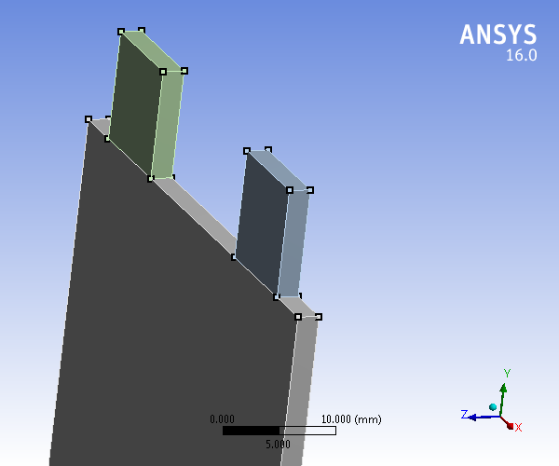

Fig.6.1 ANALYSIS OF BATTERY

**Units**

**TABLE .6.2**

|  |  |
| --- | --- |
| Unit System | Metric (mm, kg, N, s, mV, mA) Degrees RPM Celsius |
| Angle | Degrees |
| Rotational Velocity | RPM |
| Temperature | Celsius |

**Model (A3)**

***Geometry***

**TABLE 6.3  
Model (A3) > Geometry**

|  |  |
| --- | --- |
| Object Name | *Geometry* |
| State | Fully Defined |
| **Definition** | |
| Source | F:\ansys\battery_files\dp0\FFF\DM\FFF.agdb |
| Type | DesignModeler |
| Length Unit | Meters |
| **Bounding Box** | |
| Length X | 50. mm |
| Length Y | 110.04 mm |
| Length Z | 2. mm |
| **Properties** | |
| Volume | 10406 mm³ |
| Scale Factor Value | 1. |
| **Statistics** | |
| Bodies | 3 |
| Active Bodies | 3 |
| Nodes | 43272 |
| Elements | 31635 |
| Mesh Metric | None |
| **Basic Geometry Options** | |
| Parameters | Yes |
| Parameter Key | DS |
| Attributes | No |
| Named Selections | No |
| Material Properties | No |
| **Advanced Geometry Options** | |
| Use Associativity | Yes |
| Coordinate Systems | No |
| Reader Mode Saves Updated File | No |
| Use Instances | Yes |
| Smart CAD Update | No |
| Compare Parts On Update | No |
| Attach File Via Temp File | Yes |
| Temporary Directory | C:\Users\Cadd\AppData\Local\Temp |
| Analysis Type | 3-D |
| Decompose Disjoint Geometry | Yes |
| Enclosure and Symmetry Processing | No |

**TABLE 6.4  
Model (A3) > Geometry > Parts**

|  |  |  |  |
| --- | --- | --- | --- |
| Object Name | *Solid* | *Solid* | *Solid* |
| State | Meshed | | |
| **Graphics Properties** | | | |
| Visible | Yes | | |
| Transparency | 1 | | |
| **Definition** | | | |
| Suppressed | No | | |
| Coordinate System | Default Coordinate System | | |
| Reference Frame | Lagrangian | | |
| **Material** | | | |
| Fluid/Solid | Solid | | |
| **Bounding Box** | | | |
| Length X | 50. mm | 10.11 mm | |
| Length Y | 100. mm | 10.037 mm | |
| Length Z | 2. mm | | |
| **Properties** | | | |
| Volume | 10000. mm³ | 202.95 mm³ | |
| Centroid X | 25. mm | 39.948 mm | 9.8377 mm |
| Centroid Y | 50. mm | 105.02 mm | |
| Centroid Z | 1. mm | | |
| **Statistics** | | | |
| Nodes | 41472 | 900 | |
| Elements | 30459 | 588 | |
| Mesh Metric | None | | |

***Coordinate Systems***

**TABLE 6.5  
Model (A3) > Coordinate Systems > Coordinate System**

|  |  |
| --- | --- |
| Object Name | *Global Coordinate System* |
| State | Fully Defined |
| **Definition** | |
| Type | Cartesian |
| Coordinate System ID | 0. |
| **Origin** | |
| Origin X | 0. mm |
| Origin Y | 0. mm |
| Origin Z | 0. mm |
| **Directional Vectors** | |
| X Axis Data | [ 1. 0. 0. ] |
| Y Axis Data | [ 0. 1. 0. ] |
| Z Axis Data | [ 0. 0. 1. ] |

***Connections***

**TABLE 6.6  
Model (A3) > Connections**

|  |  |
| --- | --- |
| Object Name | *Connections* |
| State | Fully Defined |
| **Auto Detection** | |
| Generate Automatic Connection On Refresh | Yes |
| **Transparency** | |
| Enabled | Yes |

**TABLE 6.7  
Model (A3) > Connections > Contacts**

|  |  |
| --- | --- |
| Object Name | *Contacts* |
| State | Fully Defined |
| **Definition** | |
| Connection Type | Contact |
| **Scope** | |
| Scoping Method | Geometry Selection |
| Geometry | All Bodies |
| **Auto Detection** | |
| Tolerance Type | Slider |
| Tolerance Slider | 0. |
| Tolerance Value | 0.3022 mm |
| Use Range | No |
| Face/Face | Yes |
| Face/Edge | No |
| Edge/Edge | No |
| Priority | Include All |
| Group By | Bodies |
| Search Across | Bodies |
| **Statistics** | |
| Connections | 2 |
| Active Connections | 2 |

**TABLE 6.8  
Model (A3) > Connections > Contacts > Contact Regions**

|  |  |  |
| --- | --- | --- |
| Object Name | *Contact Region* | *Contact Region 2* |
| State | Fully Defined | |
| **Scope** | | |
| Scoping Method | Geometry Selection | |
| Contact | 1 Face | |
| Target | 1 Face | |
| Contact Bodies | Solid | |
| Target Bodies | Solid | |

***Mesh***

**TABLE 6.9  
Model (A3) > Mesh**

|  |  |
| --- | --- |
| Object Name | *Mesh* |
| State | Solved |
| **Display** | |
| Display Style | Body Color |
| **Defaults** | |
| Physics Preference | CFD |
| Solver Preference | Fluent |
| Relevance | 0 |
| **Sizing** | |
| Use Advanced Size Function | On: Curvature |
| Relevance Center | Fine |
| Initial Size Seed | Active Assembly |
| Smoothing | Medium |
| Transition | Slow |
| Span Angle Center | Fine |
| Curvature Normal Angle | Default (18.0 °) |
| Min Size | Default (1.7647e-002 mm) |
| Max Face Size | 0.70 mm |
| Max Size | Default (3.52940 mm) |
| Growth Rate | Default (1.20 ) |
| Minimum Edge Length | 2.0 mm |
| **Inflation** | |
| Use Automatic Inflation | None |
| Inflation Option | Smooth Transition |
| Transition Ratio | 0.272 |
| Maximum Layers | 5 |
| Growth Rate | 1.2 |
| Inflation Algorithm | Pre |
| View Advanced Options | No |
| **Assembly Meshing** | |
| Method | None |
| **Patch Conforming Options** | |
| Triangle Surface Mesher | Program Controlled |
| **Patch Independent Options** | |
| Topology Checking | No |
| **Advanced** | |
| Number of CPUs for Parallel Part Meshing | Program Controlled |
| Shape Checking | CFD |
| Element Midside Nodes | Dropped |
| Straight Sided Elements |  |
| Number of Retries | 0 |
| Extra Retries For Assembly | Yes |
| Rigid Body Behavior | Dimensionally Reduced |
| Mesh Morphing | Disabled |
| **Defeaturing** | |
| Pinch Tolerance | Default (1.5882e-002 mm) |
| Generate Pinch on Refresh | No |
| Automatic Mesh Based Defeaturing | On |
| Defeaturing Tolerance | Default (8.8234e-003 mm) |
| **Statistics** | |
| Nodes | 43272 |
| Elements | 31635 |
| Mesh Metric | None |

***Named Selections***

**TABLE 6.10  
Model (A3) > Named Selections > Named Selections**

|  |  |  |  |  |  |
| --- | --- | --- | --- | --- | --- |
| Object Name | *tab a* | *tab b* | *cell* | *tab a1* | *tab b1* |
| State | Fully Defined | | | | |
| **Scope** | | | | | |
| Scoping Method | Geometry Selection | | | | |
| Geometry | 1 Body | | | 1 Face | |
| **Definition** | | | | | |
| Send to Solver | Yes | | | | |
| Visible | Yes | | | | |
| Program Controlled Inflation | Exclude | | | | |
| **Statistics** | | | | | |
| Type | Manual | | | | |
| Total Selection | 1 Body | | | 1 Face | |
| Suppressed | 0 | | | | |
| Used by Mesh Worksheet | No | | | | |

**EXERCISE 2 : ANALYSIS REPORT FOR MOTOR**



**Project**

TABLE 6.11

|  |  |
| --- | --- |
| First Saved | Saturday, February 15, 2020 |
| Last Saved | Monday, March 16, 2020 |
| Product Version | 16.0 Release |
| Save Project Before Solution | No |
| Save Project After Solution | No |

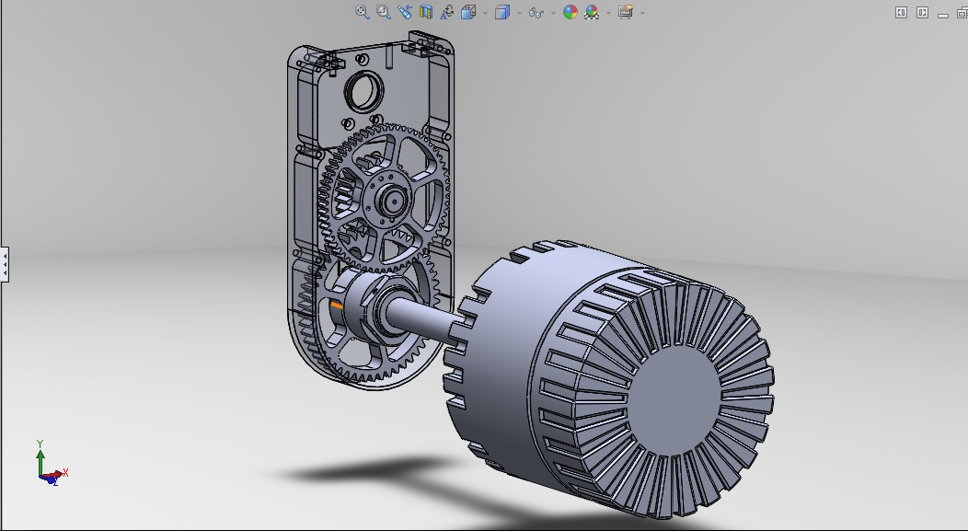

**FIGURE 6.2 BLDC MOTOR**

**Units**

**TABLE 6.12**

|  |  |
| --- | --- |
| Unit System | Metric (mm, kg, N, s, mV, mA) Degrees RPM Celsius |
| Angle | Degrees |
| Rotational Velocity | RPM |
| Temperature | Celsius |

**Model (B3)**

***Geometry***

**TABLE 6.13  
Model (B3) > Geometry**

|  |  |
| --- | --- |
| Object Name | *Geometry* |
| State | Fully Defined |
| **Definition** | |
| Source | F:\ansys\battery_files\dp0\FFF-1\DM\FFF-1.agdb |
| Type | DesignModeler |
| Length Unit | Meters |
| **Bounding Box** | |
| Length X | 50. mm |
| Length Y | 110.04 mm |
| Length Z | 12. mm |
| **Properties** | |
| Volume | 60406 mm³ |
| Scale Factor Value | 1. |
| **Statistics** | |
| Bodies | 5 |
| Active Bodies | 5 |
| Nodes | 209160 |
| Elements | 173777 |
| Mesh Metric | None |
| **Basic Geometry Options** | |
| Parameters | Yes |
| Parameter Key | DS |
| Attributes | No |
| Named Selections | No |
| Material Properties | No |
| **Advanced Geometry Options** | |
| Use Associativity | Yes |
| Coordinate Systems | No |
| Reader Mode Saves Updated File | No |
| Use Instances | Yes |
| Smart CAD Update | No |
| Compare Parts On Update | No |
| Attach File Via Temp File | Yes |
| Temporary Directory | C:\Users\Cadd\AppData\Local\Temp |
| Analysis Type | 3-D |
| Decompose Disjoint Geometry | Yes |
| Enclosure and Symmetry Processing | No |

**TABLE 6.14  
Model (B3) > Geometry > Parts**

|  |  |  |  |  |  |
| --- | --- | --- | --- | --- | --- |
| Object Name | *Solid* | *Solid* | *Solid* | *Solid* | *Solid* |
| State | Meshed | | | | |
| **Graphics Properties** | | | | | |
| Visible | Yes | | | | |
| Transparency | 1 | | | | |
| **Definition** | | | | | |
| Suppressed | No | | | | |
| Coordinate System | Default Coordinate System | | | | |
| Reference Frame | Lagrangian | | | | |
| **Material** | | | | | |
| Fluid/Solid | Solid | | | Defined By Geometry (Solid) | |
| **Bounding Box** | | | | | |
| Length X | 50. mm | 10.11 mm | | 50. mm | |
| Length Y | 100. mm | 10.037 mm | | 100. mm | |
| Length Z | 2. mm | | | 5. mm | |
| **Properties** | | | | | |
| Volume | 10000. mm³ | 202.95 mm³ | | 25000 mm³ | |
| Centroid X | 25. mm | 39.948 mm | 9.8377 mm | 25. mm | |
| Centroid Y | 50. mm | 105.02 mm | | 50. mm | |
| Centroid Z | 1. mm | | | 4.5 mm | -2.5 mm |
| **Statistics** | | | | | |
| Nodes | 41472 | 900 | | 82944 | |
| Elements | 30459 | 588 | | 71071 | |
| Mesh Metric | None | | | | |

***Coordinate Systems***

**TABLE 6.15  
Model (B3) > Coordinate Systems > Coordinate System**

|  |  |
| --- | --- |
| Object Name | *Global Coordinate System* |
| State | Fully Defined |
| **Definition** | |
| Type | Cartesian |
| Coordinate System ID | 0. |
| **Origin** | |
| Origin X | 0. mm |
| Origin Y | 0. mm |
| Origin Z | 0. mm |
| **Directional Vectors** | |
| X Axis Data | [ 1. 0. 0. ] |
| Y Axis Data | [ 0. 1. 0. ] |
| Z Axis Data | [ 0. 0. 1. ] |

***Connections***

**TABLE 6.16  
Model (B3) > Connections**

|  |  |
| --- | --- |
| Object Name | *Connections* |
| State | Fully Defined |
| **Auto Detection** | |
| Generate Automatic Connection On Refresh | Yes |
| **Transparency** | |
| Enabled | Yes |

**TABLE 6.17  
Model (B3) > Connections > Contacts**

|  |  |
| --- | --- |
| Object Name | *Contacts* |
| State | Fully Defined |
| **Definition** | |
| Connection Type | Contact |
| **Scope** | |
| Scoping Method | Geometry Selection |
| Geometry | All Bodies |
| **Auto Detection** | |
| Tolerance Type | Slider |
| Tolerance Slider | 0. |
| Tolerance Value | 0.30365 mm |
| Use Range | No |
| Face/Face | Yes |
| Face/Edge | No |
| Edge/Edge | No |
| Priority | Include All |
| Group By | Bodies |
| Search Across | Bodies |
| **Statistics** | |
| Connections | 6 |
| Active Connections | 6 |

**TABLE 6.18  
Model (B3) > Connections > Contacts > Contact Regions**

|  |  |  |  |  |  |  |
| --- | --- | --- | --- | --- | --- | --- |
| Object Name | *Contact Region* | *Contact Region 2* | *Contact Region 3* | *Contact Region 4* | *Contact Region 5* | *Contact Region 6* |
| State | Fully Defined | | | | | |
| **Scope** | | | | | | |
| Scoping Method | Geometry Selection | | | | | |
| Contact | 1 Face | | | | | |
| Target | 1 Face | | | | | |
| Contact Bodies | Solid | | | | | |
| Target Bodies | Solid | | | | | |

***Mesh***

**TABLE 6.19  
Model (B3) > Mesh**

|  |  |
| --- | --- |
| Object Name | *Mesh* |
| State | Solved |
| **Display** | |
| Display Style | Body Color |
| **Defaults** | |
| Physics Preference | CFD |
| Solver Preference | Fluent |
| Relevance | 0 |
| **Sizing** | |
| Use Advanced Size Function | On: Curvature |
| Relevance Center | Fine |
| Initial Size Seed | Active Assembly |
| Smoothing | Medium |
| Transition | Slow |
| Span Angle Center | Fine |
| Curvature Normal Angle | Default (18.0 °) |
| Min Size | Default (1.7731e-002 mm) |
| Max Face Size | 0.70 mm |
| Max Size | Default (3.54620 mm) |
| Growth Rate | Default (1.20 ) |
| Minimum Edge Length | 2.0 mm |
| **Inflation** | |
| Use Automatic Inflation | None |
| Inflation Option | Smooth Transition |
| Transition Ratio | 0.272 |
| Maximum Layers | 5 |
| Growth Rate | 1.2 |
| Inflation Algorithm | Pre |
| View Advanced Options | No |
| **Assembly Meshing** | |
| Method | None |
| **Patch Conforming Options** | |
| Triangle Surface Mesher | Program Controlled |
| **Patch Independent Options** | |
| Topology Checking | No |
| **Advanced** | |
| Number of CPUs for Parallel Part Meshing | Program Controlled |
| Shape Checking | CFD |
| Element Midside Nodes | Dropped |
| Straight Sided Elements |  |
| Number of Retries | 0 |
| Extra Retries For Assembly | Yes |
| Rigid Body Behavior | Dimensionally Reduced |
| Mesh Morphing | Disabled |
| **Defeaturing** | |
| Pinch Tolerance | Default (1.5958e-002 mm) |
| Generate Pinch on Refresh | No |
| Automatic Mesh Based Defeaturing | On |
| Defeaturing Tolerance | Default (8.8656e-003 mm) |
| **Statistics** | |
| Nodes | 209160 |
| Elements | 173777 |
| Mesh Metric | None |

***Named Selections***

**TABLE 6.20  
Model (B3) > Named Selections > Named Selections**

|  |  |  |  |  |  |  |  |  |  |  |  |
| --- | --- | --- | --- | --- | --- | --- | --- | --- | --- | --- | --- |
| Object Name | *tab a* | *tab b* | *cell* | *tab a1* | *tab b1* | *fluid1* | *fluid2* | *inlet1* | *inlet2* | *outlet1* | *outlet2* |
| State | Fully Defined | | | | | | | | | | |
| **Scope** | | | | | | | | | | | |
| Scoping Method | Geometry Selection | | | | | | | | | | |
| Geometry | 1 Body | | | 1 Face | | | | | | | |
| **Definition** | | | | | | | | | | | |
| Send to Solver | Yes | | | | | | | | | | |
| Visible | Yes | | | | | | | | | | |
| Program Controlled Inflation | Exclude | | | | | | | | | | |
| **Statistics** | | | | | | | | | | | |
| Type | Manual | | | | | | | | | | |
| Total Selection | 1 Body | | | 1 Face | | | | | | | |
| Suppressed | 0 | | | | | | | | | | |
| Used by Mesh Worksheet | No | | | | | | | | | | |

**CHAPTER-7**

**ANALYSIS IMAGES OF MOTOR AND BATTERY**

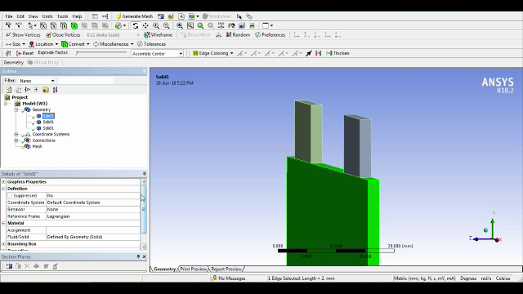

Ansys fig.7.1

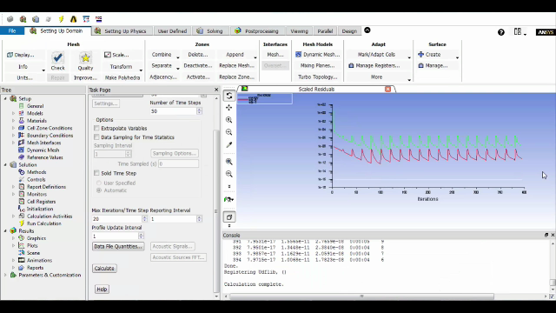

Ansys fig.7.2

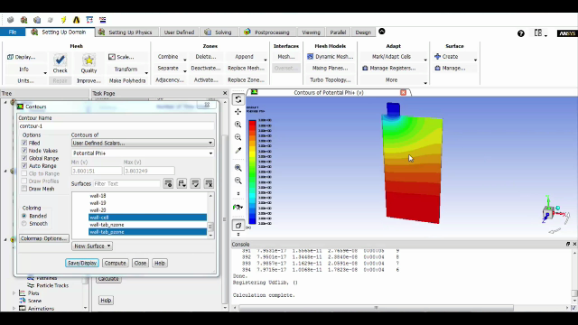

Ansys fig.7.3

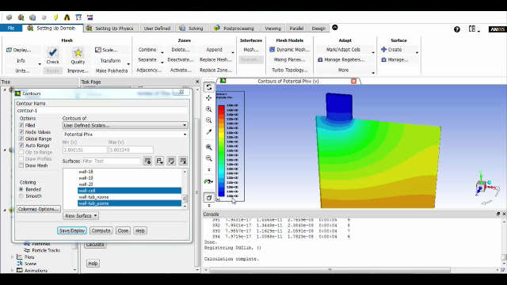

Ansys fig.7.4

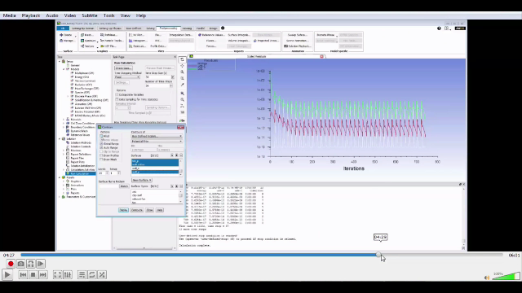

Ansys fig.7.5

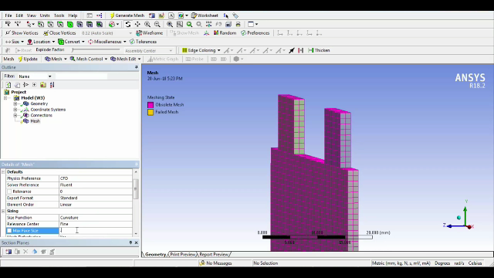

Ansys fig.7.6

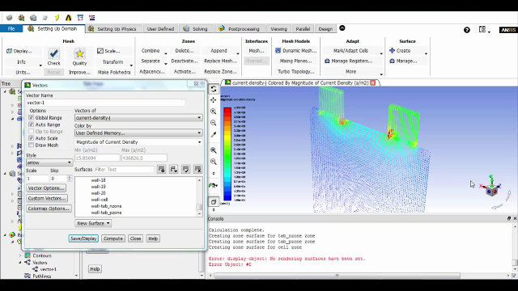

Ansys fig.7.7

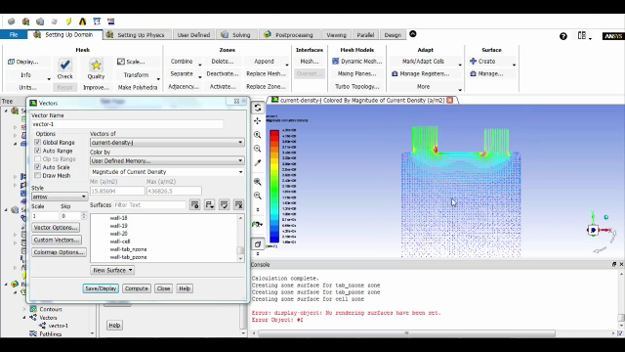

Ansys fig.7.8

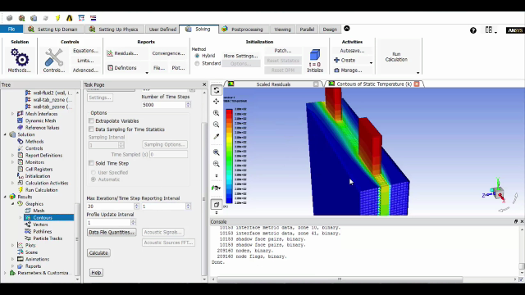

Ansys fig.7.9

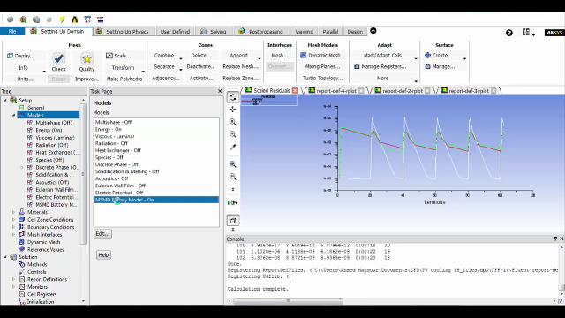

Ansys fig.7.10

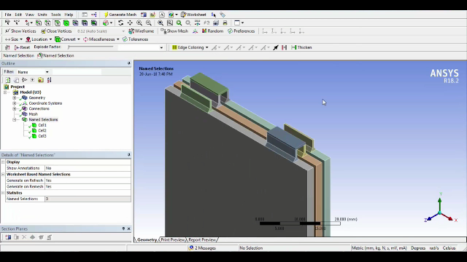

Ansys fig.7.11

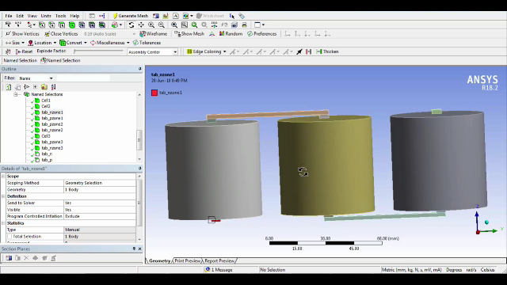

Ansys fig.7.12

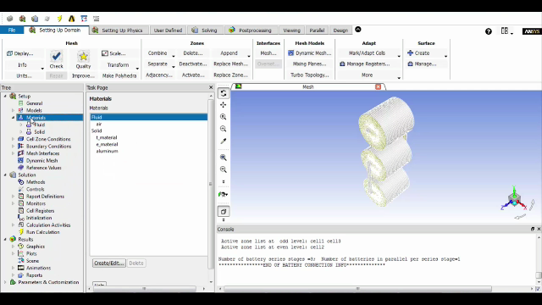

Ansys fig.7.13

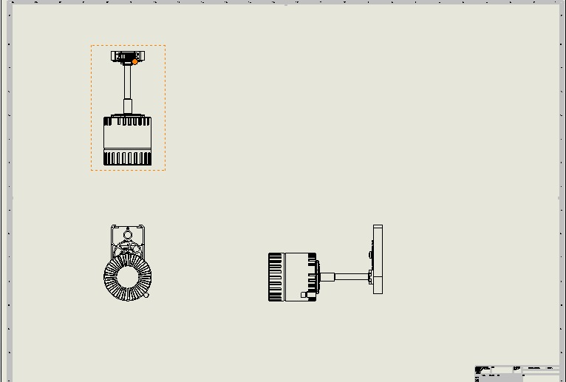

Ansys fig.7.14

**CHAPTER-8**

**CONCLUSION**

The progress that the electric vehicle industry has seen in recent years is not only extremely welcomed, but highly necessary in light of the increasing global greenhouse gas levels. As demonstrated within the economic, social, and environmental analysis sections of this webpage, the benefits of electric vehicles far surpass the costs. The biggest obstacle to the widespread adoption of electric-powered transportation is cost related, as gasoline and the vehicles that run on it are readily available, convenient, and less costly. As is demonstrated in our timeline, we hope that over the course of the next decade technological advancements and policy changes will help ease the transition from traditional fuel-powered vehicles. Additionally, the realization and success of this industry relies heavily on the global population, and it is our hope that through mass marketing and environmental education programs people will feel incentivized and empowered to drive an electric-powered vehicle. Each person can make a difference, so go electric and help make a difference!

**CHAPTER-9**

**COST ESTIMATION**

|  |  |  |  |
| --- | --- | --- | --- |
| **S.NO** | **TOPICS** | **SHORT EXPLAIN** | **COST** |
| **1** | MODELLING SOFTWARE &  GUIDE INCHARGE  FEES | We went to the cadd centre and asked them to guide and they charged some fees | **RS.3000** |
| **2** | TRANSPORT, FOOD,EXTRA ALLOWANCES | Bus fare,bike fare,food in total | **RS.1000** |
| **3** | INFORMATION  FROM COMPANY | We met staff of renault nission and asked them about the concept and arrangements and total cost to make | **RS.500** |
| **4** | COST FOR PRINT BOOKS&COMPACT DISK | Total cost for making booklets and CD for us | **RS.750** |
|  |  | **TOTAL** | **RS.5250** |

TABLE 9.1

**CHAPTER-10**

**BIBLIOGRAPHY**

1. Electric vehicles: past, present and future By Karndikar et al, International Conference on advances in energy research, IITB, 10 Dec’ 2013.

2. Connecting plug-in vehicles with green electricity through consumer demand By John, International Conference on advances in energy research, IITB, 10 Dec’ 2013.

3. Experimental analysis of 1400 cc diesel engine car converted into Hybrid Electric Vehicle by using BLDC hub motors By SudhirGupte, International Conference on advances in energy research, IITB, 10 Dec’ 2013.

4. Light weighting of Battery Electric cars: An Impact Analysis Using Indian Driving Cycle, By Muttana et al, SAE 2013-01-2831, Nov’ 2013.

5. Optimized Motor Selection for Various Hybrid and Electric Vehicles, By Sharma et al, SAE 2013-01-2833, Nov’ 2013.

6. Comparison of Indian Heavy Duty Hybrid Electric Vehicle Certification Methods with US and European Requirements By Chatterjee et al, SAE 2013-01-2873, Nov’ 2013.

7. Torque blending and wheel slip control in EVs with in-wheel motors BY Ricardo de Castro et.al. Vehicle system Dynamics, Vol- 50, September 1, 2012, P71, special issue: IAVSD Supplement (24 P, 13 fig, 1 table).

8. The Effect of Half-shaft Torsion Dynamics on the Performance of a Traction Control System for Electric Vehicles By Francesco Bottiglione et al, Journal of Automobile Engineering, Vol.226, No.9, September’ 2012, p 1145 (15 P, 13 Fig, 3 Tables).

9. Model predictive regenerative braking control for lightweight electric vehicles with in-wheel motors BY Xiaoyu Huang and Junmin Wang, Journal of Automobile Engineering , Vol. 226, no. 9, Sept’ 2012, P1220, (13 P, 18 Fig. 3 Tables).

10. Jeremy J.Michalek, Journal of Mechanical Design, Vol. 133, No. 8, August 2011, P 084502, (6 P, 2 Fig, 2 Tables).

11. EV in the context of sustainable development in China, Report by Robert Early, Liping Kang and Lucia Green-Weiskel – May’ 11 (19th Session of Commission on Sustainable Development, for United Nations Dept. of Economic and Social Affairs). CSD 19/2011/BP9.

**CHAPTER-11**

**WEBLIOGRAPHY**

1. Electric vehicle battery test and basic analysis of the given battery management system at

<http://www.arbin.com>

2. Electric vehicle basic performance and gradual power and performance at <http://www.mgmotor.co.in>

3. Analysis of the current electric battery models electric vehicles at <http://www.mdpi.com>

4. Economic analysis of battery management system at gradual specification of battery at

<http://www.ehcar.net>

5. Electric vehicle battery test and basic functions of the given battery management system at

<http://www.nmty.net>

6. Analysis of the current and individual models of electric vehicles’ at <http://www.mklo.com>

7. Electric vehicle tool based motor specification and basic subordinates of battery management system. <http://www.geotab.com>